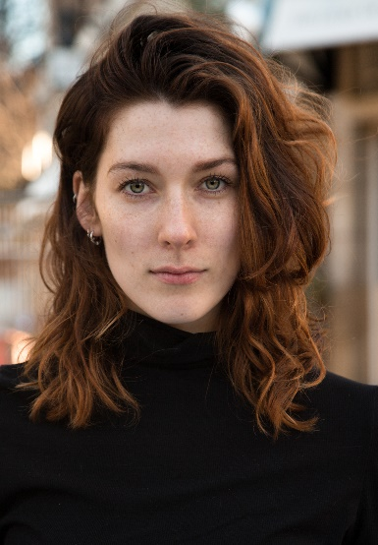
Fay Summerfield

Spotlight number - 1178-0194-2954

Training :
East 15 Acting School. BA (Hons) Acting

Nationality : British
Height : 5” 7 inches
Hair Colour : Brunette/ Auburn
Eye Colour : Green
Build : Slim Curvy

Accents / Dialects :
(*to a high standard plus native )
South Welsh* (Native), RP*, American Standard,
London, Essex.

Languages: English & Basic Welsh.

Music & Dance : Mezzo Soprano/ Alto, Music sight-reading,
Waltz, Foxtrot, Lindy-Hop, Polka, Basic Piano.

Professional Roles:
Date Character Type Production Director/Company
2018 Tiger Stage Beyond the Blue Camilla Gürtler/Cut the Cord
2018 Dancer Music Video Hearts and Colours Island Records
2017 Lover Music Video Green Light Jack Gould/Baby Chief
2017 Wife Short Film The Man I Live With Clare Baybutt
2016 Rebecca Short Film 1990 Tobias Norman/Leng Films
2016 Grace Short Film Check Ben White
2015 Lilly Ed Fringe Play Shazam Josh Husselbee

Skills:
Professional Photographer, Retoucher- Lightroom and Photoshop, Kick-Boxing (purple belt )

Other Experience :
Greek Theatre Course (2014) , Radio, Toured with Frantic Assembly, Member of National Youth Theatre of Great Britain and of Wales.

