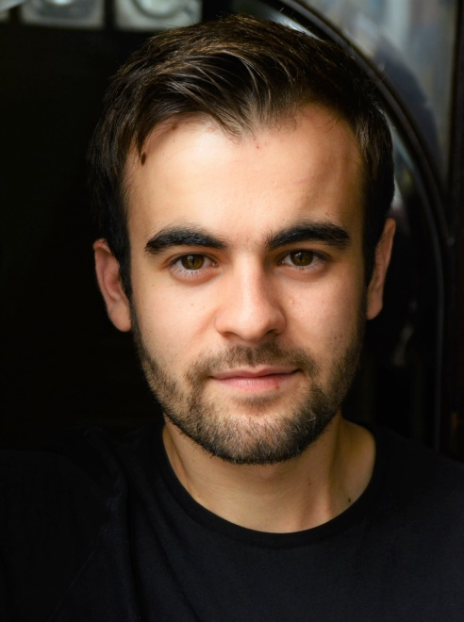
TOBY REDPATH

Description: 5ft9”, Brown Eyes, Brown Hair
Accents: London (native), Cockney, RP, Kent
TRAINING
Arts University Bournemouth, BA (Hons) Acting, 2016
SPECIAL SKILLS
Basic stage combat, Good movement skills, Basic clowning skills, Poweriser stilts, Chorus singing

THEATRE
M&M Theatrical CHARLOTTE’S WEB Avery/Scatty/ Faye McRae
Productions UK and Templeton
Ireland Tour
M&M Theatrical PETER PAN Peter Pan Paul McRae
Productions UK and
Ireland Tour
White Horse Theatre JANE EYRE Rochester Peter Griffith
German Tour
White Horse Theatre MOVE TO JUNK Donny Peter Griffith
German Tour
White Horse Theatre THE DARK LORD & THE WHITE WITCH Dilly, Slightly, Keiko Semida
German Tour Lord Morbus

THEATRE (whilst in training)
Meyrick Hall THE MAN OF MODE Shoemaker Luke Kernaghan
Pavilion Dance THE GOOD PERSON OF SCHEZWAN The Man David O’Shea
AUB Studio Theatre BLEAK HOUSE Guppy David Glass
Miskin Theatre UBU ENCHAINED 1st Free Man Denise Evans
Miskin Theatre WEST SIDE STORY Indio Robbie McGovan
Local Tour A FISTFUL OF WORDS Harry Bronagh Lagan
Miskin Theatre INTO THE WOODS Ensemble Robbie McGovan
Miskin Theatre BLOOD WEDDING Stallion Bronagh Lagan
SHORT FILM (student)
AUB Film School THE BIVOUAC Thomas Kiosa Sukami
AUB Film School THE LONG ABSENCE Mark Rumeh Ejoor
RELATED EXPERIENCE
Assistant stage manager for Festen directed by Kirsty Davis, Sound operator for Turn of the Screw directed by Katharine Piercey and Paul Knight, Workshop leader, Lighting and Sound operator on tour, Forum Theatre workshop with David Glass, Storytelling workshop with Mike Alfreds, Acrobatics workshop with Martin Gratz

