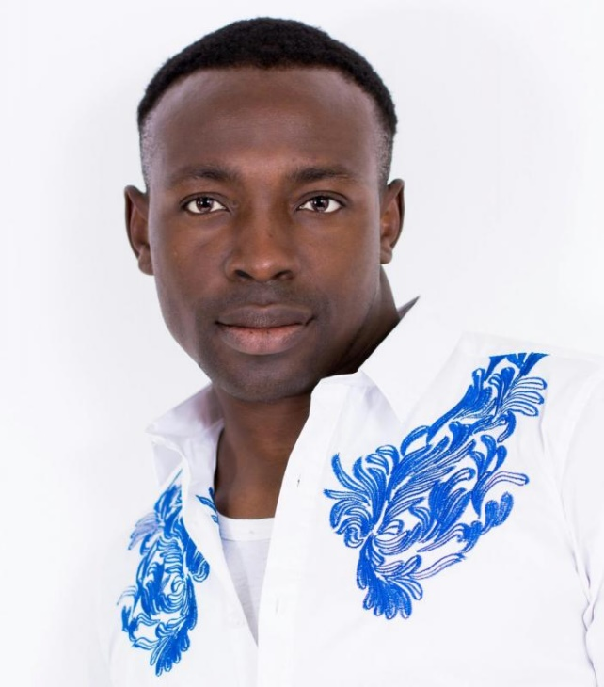
Alexander Akosile

Ethnicity Black - African
Age Range 27 - 37
Height 6' 0" (1m 83cm)
Weight 12st. 4lb. (78kg)
Hair Colour Brown
Eye Colour Black
Build Medium

Credits
2015 FINDING
Film (Feature) My Father is a Hero
Daud FD Wuriee Angeles Pictures Inc Limited
London and Essex
2015 1980's Security Guard
Corporate Bluecrest Summer Party
Courtney Lewis Cow Events
London
2015 Supporting Artist/Shopper
Commercial Transformation/Shopping Scene
WiGz Fifty Mill Pictures
London
2015 Panel of judges
Film (Docu) Drama Series
CC
2015 Supporting Artist
Film (Docu) Drama Series
G&D
2015 CIA Agents
Film (Feature) Tarus
2020 Casting
2015 Background Artists
Commercial Barclays commercial
NYSM
2014 Family Member
Film (Feature) The Good Son
Tomisin Adepeju Met Film
London
2014 Family Member
Film (Feature) Good Son
Tomisin Adepeju Met Film
London
2014 Kuba Villager & Prisoner
Film (Feature) Tarzan
Hannah / David Mad Dog Casting
Harry Potter Village Hall. Watford Junction
2014 Boy With Attitude
Theatre Little Revolution
Joe Hill-Gibbins Almeida Theatre
Almeida Theatre, Islington North London.
Education
YearQualification
Where
20183 yr. Acting
Kogan Academy of Dramatical Art
2014Introduction to Acting short term (3 months).
Skills
Skin Colour Black
Hair Length Short
Native accent English
Accents (UK) Cockney, English, standard, London, South London
Accents (North American) General American
Accents (International) African (West), Nigerian
Languages Spoken English, Yoruba
Interested in Comedy, Commercials, Corporate, Film (Professional), Improvisation, Modelling, Music Videos, Online, Roleplay, Theatre (Fringe), Theatre (Professional)
Experienced in Commercials, Corporate, Film (Professional), Modelling, Music Videos, Rehearsed Readings, Roleplay, Theatre (Fringe), Theatre (Professional)
General Singing Skills Solo
Specific Singing Skills Baritone
General Dance Skills African dance styles, Contemporary, Hip Hop, Jazz
Musical Skills Bass, Guitar
Stage Combat Skills Intermediate
Perform nude? No

