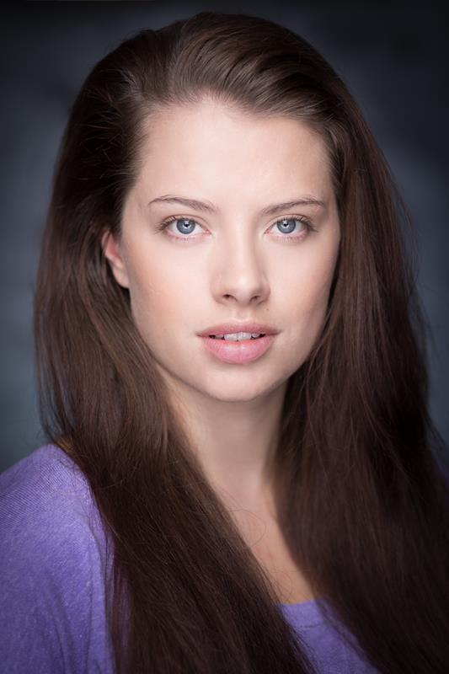
Alexandra Ford
Flat 10, 123 London Road, High Wycombe, HP11 1BT
07733222296
Alexford96@gmail.com
Equity: 00321105
Spotlight: http://www.spotlight.com/0518-7869-4826
Eyes: Blue Hair: Long Brown Height: 5’8”
Weight: 9st 2lbs Playing age: 18-25
Training
Brunel University, BA Theatre (Hons), Sept. 2013- July 2016
Performance experience
Year Role Production Director Company
2018 Acolyte Fantastic Beasts AWTFT2 David Yates Warner Bros UK
2017 Leah Ellie Allie Sarah Pearce Bucks’ Films
2017 Sarah Shadow Chris Walton CPW Films
2017 Ana A Monster Alexandre Do Overdrive Pictures
2017 Emily Le Page Retribution Robin Crow Bucks’ Films
2017 Football fan Justice League Zack Snyder DC Comics
2016 Crystal Flake Christmas at Blenheim Sadie D-Spain TWTC
2016 VIP Festival goer Kingsman: The Golden Circle Matthew V. Cloudy Production
2016 Lisa Kill Me Now Frederico C. Constance G.
2016 Audience Episodes David Crane HatTrick Production
2015 Woman 4 Edges: A Song Cycle Broderick C. Brunel Uni.
2015 Trudy Hello Sam Charles Kane Charles Kane
Skills
Accents: RP English, Bristol, Cockney, Gloucester, Irish, Scottish, Welsh, American, Australian
Music and dance: Alto, rap, choreography, dance (general), hip hop
Sports: Cheerleading, gymnastics, aerobics, running, swimming, skiing, horse riding, archery
Full UK driving licence

