ALEXANDRA KHAN

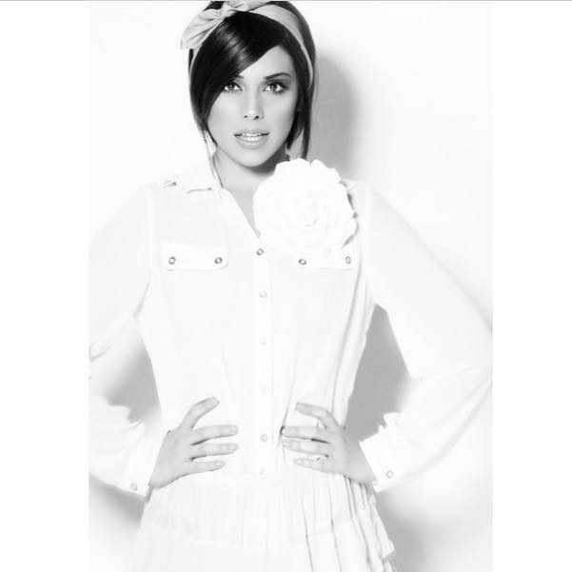 Eyes: Brown

Hair: Dark Brown Height: 5’5’’

Accents
Native*: RP, American-California, American-New York, Cockney, Essex*,London

Skills
Movement: Aerobics, Choreography, Contemporary Dance, Jazz Dancing, Thai Kick-Boxing, Zumba.
Strong on improvisation.
Performance: TV Presenting
Sports: Roller-Skating, Yoga, Swimming

FILM:
Paper Sun Films MISSED CONNECTIONS (Madame Monet) Christopher Presswell
Dangerous Productions Ltd BASELINE (Emma) Brendon O'Loughlin
KOR Films NOT QUITE A DREAM (Amy) Sean Phillips
Red Mullet BIZZNESS WOMAN (Bizzness Woman) Mike Figgis

TELEVISION:

MTV Base FROM THE ENDZ (Model) Chris Phillips
MTV Flux FIT AS FLUX (Presenter) Chris Phillips
MTV Dance GOOD GREEF PROJECT (Presenter) Paul Joseph
BBC1 TOP GEAR SPORT RELIEF (Dancer) Various
BBC1 INSIDE OUT (Youth) Patricia Williamson

COMMERCIAL/ CORPORATE/ MUSIC VIDEOS:

Bacardi BACARDI GET TOGETHER (Main Friend) Mark Heller
Panasonic PANASONIC (Mum) Various
Ghinzu Take It Easy (Mystic) The Lennox Brothers
HST POWERS (Superhero) The Lennox Brothers
Fei Comodo BEHIND BARS (Model) Chris Phillips
Plan B MISSING LINKS Paul Gore
FHM GIRLS OF FHM (Model) Brian Mays

Wax Productions HALLMARK (Young Mum) Simon Gargette
Nokia Internet Service NOKIA (Girl on Phone) Hugh IP
EDF RUGBY WORLD CUP (Model) Various
Brave Films DOVE SHAMPOO (Client) Various

STAGE:

Black Country
Living Museum AND THEN ONE DAY AN ANGEL CAME (Victoria) Dawn Huxley
Arena Theatre ELLA V’ LIFE (Ella) Alexandra Khan
Braintree Theatre LITTLE SHOP OF HORRORS (Principal Dancer) Alie Brynn
Braintree Theatre OEDIPUS (Citizen) Stuart Grant

