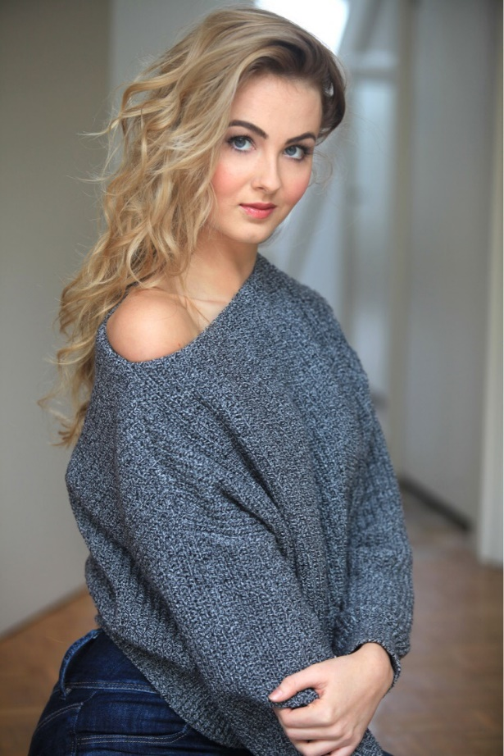
Amber St Cliere

DOB: 26/6/1998
Height: 5’9
Dress size: 6/8
Weight: 56 kg
Hair colour: Blonde
Eye colour: Grey
Ethnicity: British
Playing age: 16-21
Accents/ Dialects: RP, Essex, general American

Training/ education:
GCSE & A level Drama
ISTD examinations up to Grade 5 in Ballet, tap and Modern

Performance experience:
- Ensemble cast in devised drama piece “The Jury” 2014 GCSE, public and assessed performance.
- 2 minute Monologue from the play “Cigarettes and Chocolate” 2015 A level, public and assessed performance. (Available on request)
- Ensemble cast in play “Blue Stockings” 2015 A level, public and assessed performance.
- Ensemble cast in devised Drama piece “The seminar” 2016 A level, public and assessed performance.
- 2 minute monologue from the play “Cymbeline” by William Shakespeare 2016 Public performance. (Available on request)
- Annual dance shows with dance school from 2006-2015

Skills/ Abilities:
- Dance- ballet, basic pointe work, modern, tap, jazz, contemporary, musical theater, commercial, heels.
- Aerial- basic hoop, trapeze, silks, pole.
- Other- Horse-riding, yoga, biology (studying biology Bsc degree), UK driving license, swimming.

