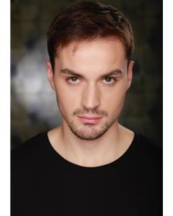
BILLY J TWOMEY

Location: London, Middlesex, United Kingdom
Height: 6'2" (187cm)
Weight: 12st. 6lb. (79kg)
Playing Age: 16 - 25 years
Appearance: Mediterranean, White
Eye Colour: Brown
Hair Colour: Dark Brown
Hair Length: Short
Voice Quality: Clear
Voice Character: Friendly
Credits:
2018, Feature Film, Plague Doctor, BAD IMPULSE, All In Films, Michelle Danner
2018, Feature Film, Policeman, LADY IN RED, Courage Films, Hannah Giannini
2018, Feature Film, Chase, RELEASE, Godiva Films, Simon Rickards
2018, Short Film, Gerwyn, INSTANT RISK, Buppha Witt Productions, Buppha Witt
2018, Short Film, Stuart, ONE MORE TOM COLLINS, Axis Films, Seung-Ju An
2017, Short Film, Ricky, AMBER, Mervingion Productions, Andi Osho
2017, Short Film, David, THE PURIST, Relativity Education, DJ McCoy
Skills:
Accents & Dialects:
(* = native) American-Midwest, American-New York, American-Southern States, American-Standard, Central Scottish, Cockney, Cork, Dorset, English-Standard, Essex, Hampshire, Irish-Southern, London, RP, Scottish-Standard
Languages:
(* = Native/Fluent) English
Music & Dance:
(* = highly skilled) Baritone, Contemporary Singing, Falsetto, Guitar, Ukulele
Performance: Actor-Musician, Actor-Singer, Adler Technique, Children's Theatre, Comedy Improv, Meisner Technique, Theatre In Education, Voice Acting
Sports:
(* = highly skilled) Athletics, Boxing, Callisthenics, Climbing, CrossFit, Cycling, Fitness Instructor (qualified), Football, Running, Swimming
Vehicle Licences: Car Driving Licence
Other Skills: Alexander Technique, Barista (experienced), Improvisation, Lifeguard, Personal Trainer-qualified
Training:
Edgemar Center for the Arts, Acting, 1 year, 2017 - 2018

