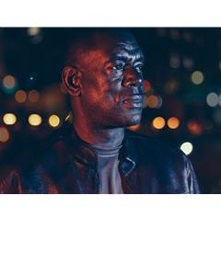
CLIFF BROWN

Location: London
Height: 5'10" (177cm)
Playing Age: 41 - 50 years
Appearance: African-American, Black-African, Black-Caribbean
Nationality: British
Eye Colour: Brown
Hair Colour: Black
Hair Length: Short
Voice Quality: Clear
Credits:
2013, Television, Tommy Campbell, HOLBY CITY, BBC Television, Richard Signy
2013, Feature Film, Mike Ellis, Detective Assistant, THE ATTACHMENT, Black Eagle Films, Clement Ofoedu
2016, Documentary, Narration, ST MARK'S CHURCH CHOIR ETON TO HACKNEY, AfroCommotion, Colin Gerald
2017, Short Film, Peter, HOMEWARD, A GC Production, Jack Blanch
2014, Short Film, Security guard, WHAT IF NOT, RCA, Lukas Franciszkiewicz
2016, Commercial, Friends, RATTLING STICK, British Heart Foundation, Ed Morris
2015, Commercial, Hand Model, ASDA SUMMER PRODUCE + BRANDS YOU LOVE BATCH, VCCP KIN, Chris Chaundler
2014, Commercial, Watch Maker, ECOBANK, The Bare Flim Company, Fred Garson
2014, Commercial, Office Manager, MINI ROAST, Eblex, Matt Waller
2015, Still Photography, Hand Model, BAYER, Making Pictures, Tom Van Schelven
2014, Music Video, Boss, SEWER SIDE FAME MUSIC, Indigo Rebel, Neill Francis
2014, Still Photography, Man, SANTANDER (ONLINE), WCRS
2013, Still Photography, Hand Model, SAMSUNG, Work Production Company, Sandro Miller
Skills:
Accents & Dialects:
(* = native) African, American-New York, Caribbean, English-Standard, Jamaican, London
Sports:
(* = highly skilled) American Football, Badminton, Basketball, Football, Golf, Swimming
Vehicle Licences: Car Driving Licence
Other Skills: Disc Jockey (professional), Narration
Training:
City Lit, Advanced Camera Work, 2013 - 2013

