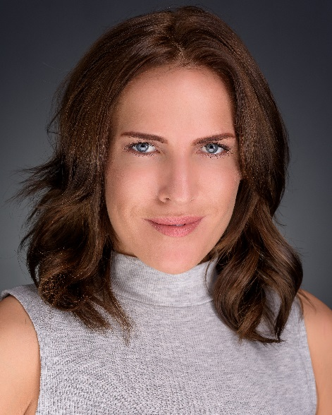
Skills
Playing age : 25 – 35 height : 5’5 eyes : blue / grey hair : brown
Singing : Mezzo soprano
Dance : A level contemporary, cabaret, jazz
Accents : RP, general American, Yorkshire, Manchester, Birmingham, Cockney , Scottish
Other : Improvisation , script writing , directing , children entertainer , singer
Full clean driving license CRB

SPOTLIGHT : 1175-7864-5338 EQUITY : M00267133

Stacey Lynn Crowe
www.staceylynncrowe.com
staceycrowy_06@hotmail.co.uk
9 Nelson Street, Burton upon Trent, Staffordshire, DE15 0DE

TRAINING
BA Hons Musical Theatre and drama – Cumbria Institute of the Arts 2:1
National Diploma Performing Arts – Burton College Distinction

PRODUCTION ROLE DIRECTOR COMPANY
TV
2017 - SHAKESPEARE & HATHAWAY Photographer Ian Barber BBC
2017 - AUTOPSY Carol Kaufman Steve Webb Channel 5
2017 - DOCTORS Veronica M.Fraser BBC
2016 - USED CAR WARS Car buyer Renegade Pictures DAVE TV
2015 - PEAKY BLINDERS Escort Nancy Colm McCarthy BBC2

Commercial
2017 - SCREAMFEST Victim Rosie Faith National Forest Adventure Farm
2016 - RAPID HOME SECURITY Mother Lucy Mason Webeye
2016 - SKY SPORTS Business woman Oliver Wurffell Sky Sport Italia
2016 - VISIT ENGLAND Tourist Paul Ellener Motiv Productions

Film
2016 - LOSING FAITH Sammy Grant Steve Wood Redtrack Productions
2016 - OUR GAL Our Gal Stacey Lynn Crowe Beeston Film Festival
2016 - THE MINES Lilian Emma Simms Scribbles & Scrawls
2016 - GHOSTS PC Bennett Denise Lambert Enigma Productions
2016 - ROAD PC Taylor Nasif Ali T World Productions
2015 - AM I BEAUTIFUL NOW Aphrodite Carys Wall Maverick TV
2015 - THE GIRL WITH ALL THE GIFTS Hero Hungry Colm Mcarthy Altitude Films
2012 - ENTITY Gemma Jim Mcgovern Five Lamps 24h Film

Theatre
2017 - PIRATES OF THE MAIZE MAZE Georgette Fowler Rosie Faith National Forest Adventure Farm
2017 - MAD HATTERS TEA PARTY Queeny Annabelle Ward Fancy Entertainment
2014 - DICK WHITTINGTON Miss Moffit Christopher Penn The Actors Company
2014 - MR BLOOMS ALLOTMENT Miss Blossom Peter Cliff CBBC
2013 - CINDERELLA Suzanna Ugly Sister Claire Farr The Panto Company
2013 - THE CASTLE DUNGEONS Various Medieval Donna Cooper Merlin Entertainments
2009 - A NIGHT AT THE MUSICALS Lead Stacey Lynn Crowe The Turtle Shack LTD
2008 - THE ORDINARY LIFE Shirley Stacey Lynn Crowe Stanwix Arts Theatre
2008 - ANIMAL FARM Clover Jenny Gould Stanwix Arts Theatre
2007 - SWEENEY TODD Lucy, Beggar woman Richard Milbourne Shortback Productions
2007 - TWO GENTLEMEN OF VERONA Panthino / Hostess Dr Robert Leech Stanwix Arts Theatre

Corporate / live performance
2016 - XTREME SCREAM Patty Annabelle Ward Fancy Entertainment
2016 - HALLOWEEN CURSE Marcella Annabelle Ward Fancy Entertainment
2016 - WHO KILLED CHAT SPITT ? Irvana Tickle Jayne Rickard Lucky Arrow Productions
2015 - SPOOKTACULAR Clawdia the cat Sali Greasham National Forest Adventure Farm
2015 - MURDER AT THE ABBEY Ida Down Jayne Rickard Lucky Arrow Productions

