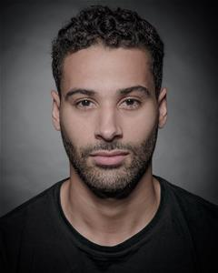
DANIEL WILDMAN

Location: London , United Kingdom
Height: 6' (182cm)
Weight: 12st. 7lb. (79kg)
Playing Age: 21 - 30 years
Appearance: Mediterranean, Middle Eastern, Mixed Race
Eye Colour: Brown
Hair Colour: Dark Brown
Hair Length: Mid Length
Voice Quality: Clear
Voice Character: Engaging
Credits:
Television, Darren Reid, HOLBY CITY, BBC, Rob Evans
Television, Danny Croft, SCORED (PILOT), Fremantle Media Ltd, Owen Matthews
Stage, Gabriel, SUGAR & SPICE, Futures Theatre Company, Caroline Bryant
Stage, Daniel, ACCIDENTAL HEROES, Lyric Young Company, Mark Murphy
Radio, Lucas, LYSISTRATA, BBC Radio, Graham Whitlock
Skills:
Accents & Dialects:
(* = native) American-New York, Cockney, Jamaican, London, Middle Eastern, RP
Sports:
(* = highly skilled) Athletics, Basketball, Boxing, Cycling, Football, Martial Arts, Rugby, Swimming, Tennis, Weight Training
Vehicle Licences: Car Driving Licence
Other Skills: Photographic Model

