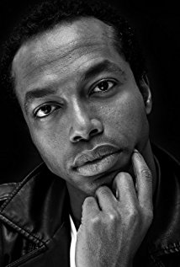
Fatah Ghedi
Fatah Ghedi is an actor, known for Ready Player One (2018), Stan Lee's Lucky Man (2016) and In Darkness (2017).

Credits:
Ready Player One (completed)
Sixer
2017 Camera Café (TV Series)
Aziz
- Caporale mio caporale (2017) ... Aziz
- Progetto Piadina (2017) ... Aziz
2017 Liar (TV Series)
Postman
- The White Rabbit (2017) ... Postman
- I Know You're Lying (2017) ... Postman
2017 Episodes (TV Series)
Kojo
- Episode Four (2017) ... Kojo (uncredited)
- Episode Three (2017) ... Kojo (uncredited)
- Episode Two (2017) ... Kojo (uncredited)
- Episode One (2017) ... Kojo (uncredited)
2017 American Assassin
CIA Target (uncredited)
2017 Stan Lee's Lucky Man (TV Series)
Runner
- Second Chance (2017) ... Runner
2017 Silent Witness (TV Series)
North African Smuggler
- Identity: Part 2 (2017) ... North African Smuggler
- Identity: Part 1 (2017) ... North African Smuggler
2017/I In Darkness
Protester
2011 Cosi fan tutte (TV Series)
Pharmacist
- Episode dated 31 October 2011 (2011) ... Pharmacist
2010 All Stars (TV Series)
Samuel
- Chi la fa l'aspetti (2010) ... Samuel
- Siamo tutti fratelli (2010) ... Samuel
2006 Il mercante di pietre
2nd Somali (as Abdifatah Ghedi)
2002 Rosa Funzeca
Haled

