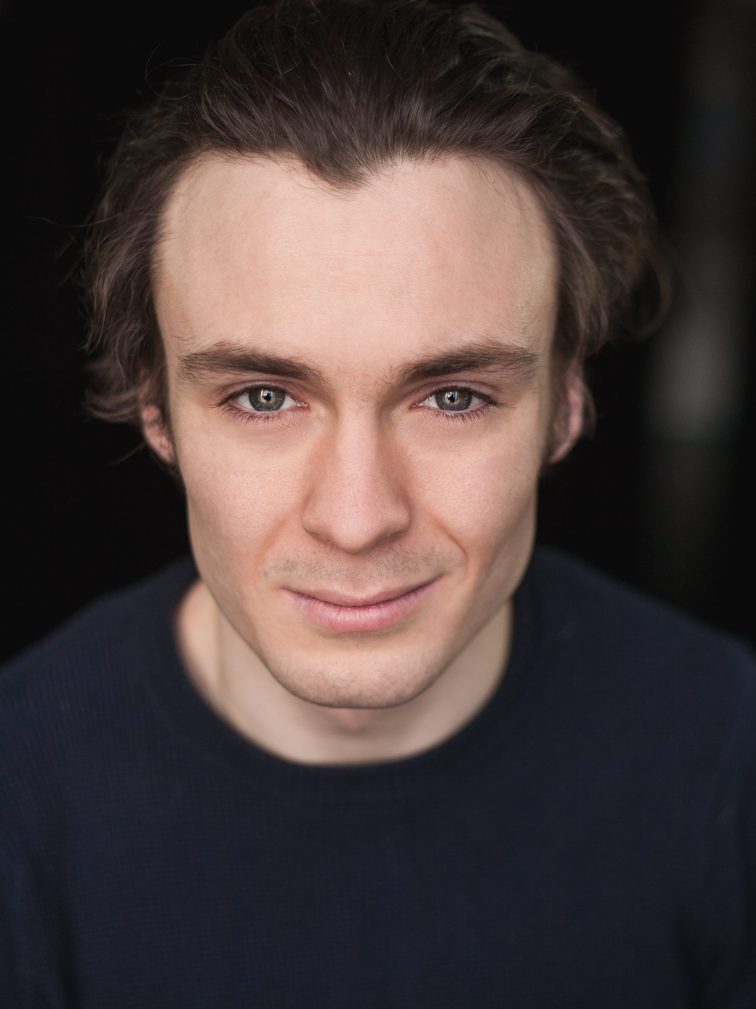

Henry Esdon

Actors CV 2018

Training: University of Central Lancashire,
National Youth Theatre

E-mail: henry.esdon@yahoo.com
Website: http://henryesdon.wix.com/henryesdon
Phone: 07415274994
Spotlight: 1891-3491-9078
Equity: SS00437101

Location: London
Height: 5’8”
Build: Medium
Hair: Brown
Eyes: Blue – Green
Dir. Raef Braitwaite
Dir. Nic Phillips
Dir. Savvas D. Michael
Dir. Samantha Allen
Dir. Jimmy Dean
Dir. Phillip Wood
Dir. Padraig Mac Anraoi
Dir. Peter Hannigan
Dir. Padraig Mac Anraoi
Dir. Anna Aslanova
Dir. Ant Barnes
Cierto Productions
Histrio House
Liontari Films
Inferior Films
Jimmdeanfilms
UCLan
UCLan
UCLan
UCLan
Fridge Productions
Dark Skies Media

Re-Track
The Daily Grind
Red Devil
Phase 7
V
When Harry Wet Sally
Guilt
The Boys
The Come-Down
Last Orders
If I Had all the Shame
Television/Film

Benjamin
Rich
Red Addict
Doctor
Supporting Role
Conrad
Harry
Jordan
Friend
Josh O’Mara
Lewis

Dir. Sue Halton
Dir. Luna Rose
Dir. Sam Gooding
Dir. Lynda Clarkson
Dir. Georgia Orzel
Dir. Guy Hargreves
Dir. Aiden Condron
Dir. Terence Mann
Dir. Mark Whitelaw
Dir. Darren Tunstall
Dir. Sarah Stone

Piper Senior Theatre Company
Edinburgh Fringe Festival
Corby Cube
Lytham, St Annes
Salford (Tour)
Media Factory, UCLan
St Peters Arts Centre, Preston
Media Factory, UCLan
Media Factory, UCLan
St Peters Arts Centre, Preston
Media Factory, UCLan

I Love You Mum I Promise I Won’t Die
StarFish
By Way of Pain
A Midsummer Night’s Dream
Life
Dead Body Disposal for Dummies
The Seagull
Mad Forest (excerpt)
The Strangeness of Others
The Way of the World (excerpt)
The Three Sisters (excerpt)
Theatre:
Tim
Adam
Edward
Demetrius
Josh
Barry Rampton
Konstantin Treplev
Radu
Josh
Young Witwoud
Andrei Prozorov

Other:

Participant
Ian
Participant
Participant
Tim
Participant
N.Y.T Senior Course
Performer
Role Play
Radio Extract
Radio Extract

National Theatre
Lost in Motion
D&G Network Event
Soho Works
National Youth Theatre
The Pappy Show
National Youth Theatre
National Theatre
Media Factory, UCLan
Media Factory, UCLan
Media Factory, UCLan

Pericles (R&D)
By Way of Pain (Scratch Night)
Casting Workshop with Alison Solomon
Workshop with Dir. Lewis Arnold
Fathers Inside/50 Plays In a Day
Movement Workshop
Devised Performance
WeAreHere
Patient
Scenes from The Big Picture
Private Peaceful
Radio/Voice Over

Blake
TV Product Seller
Main Character

Three-Minute Stop Motion,
Short Animation,
Mouth,
UCLan Animation
UCLan Animation
UCLan Animation
Dir. Rosie Nelson
Dir. Declan Holgate
Dir. Liam Springthorpe

Skills:

Meyerhold’s Theatrical Biomechanics, Shakespeare & Classical Acting, Animal Studies/Yoga, Clowning, Mask Work (Trestle), Stanislavski Techniques, Meisner Techniques, Strasberg Techniques, Chekhov Techniques, Artaud Techniques, Brechtian Theatre, Viewpoints, Improvisation, Choreographic Theatre, Stage Combat, Performing for Radio, Acting for the Camera, TV Performance, TV Casting (Workshops), Puppetry, Physical Theatre

Emily Lin
Sam Gooding
D&G Network
Lewis Arnold
Ashley Rose
Kane Husbands
Kane Husbands
Jeremy Deller & Rufus Norris
Pharmacy Department
Terence Mann
Terence Mann

Accents & Dialects: | (* = Native) Estuary English, *London, RP. American, Liverpool, Irish (Dublin), Scottish
Music & Dance: | Drums (Beginner), Piano (Beginner), Guitar (Beginner)
Sports: | (Highly Skilled=*) *Rugby, Judo, *Cross-Country (Running), Athletics, Canoeing, Swimming,
Vehicle Licences: | Full Clean Car Driving Licence (UK)
Other Skills: | *Shooting, Archery, *Gym (Weight Lifting, Athlete Standard), Gymnastics (Intermediate), Creative Writing, Gardening, Photography, Scuba Diving, *Hiking (Bronze & Silver Duke of Edinburgh), Survival Skills, *Cycling

