JASMINE HENRICSON
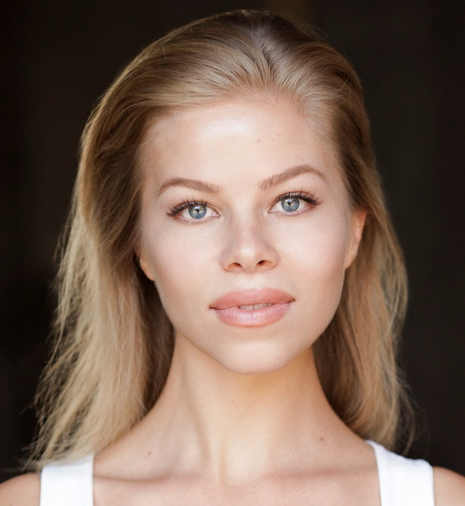

Training
Sylvia Young Theatre School- Acting technique
ACS Hillingdon- Two year drama course

Physical Attributes
Height- 5’6
Weight- 50kg
Build- Petite
Hair- Ash Blonde
Eye: Blue
Playing Age: 16-26

STAGE
2018, A Class Act, Sarah, Barnes Theatre Company, Andy Yeates
2012, Taming of the Shrew, Bianca, ACS Hillingdon, Paul Larochelle

FEATURE FILM
2018, 8ish, Bar Maid, Slammer Productions, Luing Andrews
2011, Moments of Fiction, Lesley, MM Productions, Mohammed Mamdouh

SHORT FILM
2018, Horror of Wonderland, Wendy, Andrew Bury
2018, Tower P, Ella, Channel 4, Kent Hugo
2018, The Blood of a Saint, Sunshine, National Film and Television School, Ivana Anastasovska
2017, Meet You There, Lilly, Miller 29, Chris Miller

COMMERCIALS
2017, Christ Jewellery, Featured, Progress Films, Joe Bidmead
2016, Wow Protein, Featured, Hamish Stephenson, Hamish Stephenson

MUSIC VIDEOS
2018, Martyr, Lead, VNDTA, Rachel Clarkstone

Accents English RP, standard American, French
Music Soprano, Alto
Dance Ballet, Hip Hop, Salsa, Argentinian Tango
Sports Advanced Horse Rider (Competitive Show Jumper), Licenced Scuba Diver, Tennis, Skiing, Golf, Surfing
Other Won a Performing Arts Scholarship to HurtWood House and was accepted to the Theatre Program at Northeastern University in Boston, Massachusetts.

