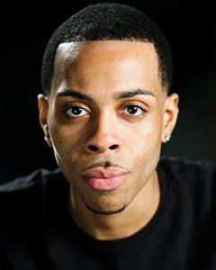
KURT CAMPBELL

Location: London, Middlesex, United Kingdom
Height: 6' (182cm)
Weight: 13st. 12lb. (88kg)
Playing Age: 21 - 30 years
Appearance: Black-Caribbean, Mixed Race
Nationality: British
Eye Colour: Brown
Hair Colour: Black
Hair Length: Short
Facial Hair: Goatee
Voice Quality: Gentle
Voice Character: Natural

Credits
Feature Film, Kenny, FRESH DECK, La Lloyd
Internet, Reece, TRIM, AEA Films, Anthony Abuah
Stage, Yasha, THE CHERRY ORCHARD, Cockpit theatre, Jane Swift
Short Film, Tom, NO NEW MEMORIES, David Moyle
Music Video, Rapper, ANVA RAP TUNE, Sachin Parmar
Documentary, Ugandan soldier, BLACK OPS, Yesterday
Music Video, Lead, DEM MAN DOU - J-FRESH, RED DEVIL FT KILLA P & FRISCO, Link Up TV, Chiba Visuals

Skills:
Accents & Dialects:
(* = native) American-New York, Caribbean, Cockney, Essex, Jamaican, Sheffield
Performance: Comedy
Sports:
(* = highly skilled) Athletics, Basketball, Bowling, Cricket, Fitness Instructor (qualified), Tae Kwon Do
Training:
City of Westminster: 2009 - 2012

