LUCY CAMACHO

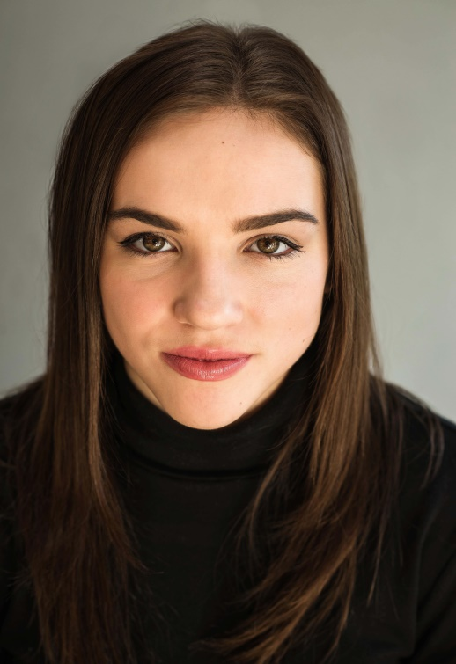
PROFILE LINKS:

IMDB: http://www.imdb.com/name/nm7954474/
Talent Talks: http://www.talenttalks.co.uk/profile/lucy-camacho/ Backstage: www.backstage.com/u/LUCY-CAMACHO
Star Now: https://www.starnow.com.au/profile/
Mandy Actors: https://actors.mandy.com/uk/actor/profile/lucy-camacho

Role types: White
Hair: Brown
Hair length: Mid length
Eyes: Hazel

Location: Kent
Height: 5’4 (1.63m)
Weight: 8.5st (119lb)
Playing age: 16-21 years

THEATRE

Project/Production Role Director
Jezebel Robin Paul Ackroyd
Spring Awakening Aardvark/Ina Tim Crowther
Fair to Middling Narrator Elliott Edusah
After the Storm Caleb Sarah Goodall
As You Like It Hymen Tim Crowther
A Doll’s House Nora Tim Crowther
Wizard of Oz Dancer Debbie Fyffe

TV, FILM & RADIO

Project/Production Role Production Company/Distribution Channel
Jaguar TVC Extra Spark 44
Shrey Singl Music Video Girlfriend (lead feature) Double A
Stormzy Music Video Extra Talent Talks
BBC Election Trial TVC Feature BBC
‘Confinement & Liberation’ Fashion Film Lead UCA (Student film)
The Rizen 2 (IMDb credited) Facility Admin staff Lost Eye Films

EDUCATION & TRAINING

Acting: Cossons School of Performing Arts 18/09/2017-Present 3 Year Musical Theatre Course,
The BRIT School for Performing Arts – (2011-2015), Debbie Fyffe Theatre School (2009-2010), Associated Studio intensive four week course by Tutor/Actor Jason Riddington
Voice: The BRIT School for Performing Arts – (2011-2015) American accents with Nina Zendejas (2016)
Movement: Studied physical theatre at The BRIT School for Performing Arts – (2011-2015)
Dance: The BRIT School for Performing Arts – (2011-2015) Debbie Fyffe Theatre School (2009-2010)
Shimmi Shake Dance Academy (2007-2009) Stage Combat: The Poor School (2016)

SPECIAL SKILLS

Dancing: Commercial, Contemporary, Modern, Jazz and Freestyle
Sports/Hobbies: Swimming, Horse riding, Aerobics, Yoga, Pilates, Boxing, Circuit training, Running
Accents: American-California, American-South America - General, RP, Essex, Irish, Northern
Languages: English (fluent), Spanish (basic-intermediate level)

UK Driving Licence and own car
CRP checked previously worked with children

OTHER EXPERIENCE

Taught drama and dance to children age 3-10
Runner placement at ITV
Writing workshop with Tim Crouch
Young people’s opportunities with National Theatre
Workshops at Oval House and Almeida Theatre

