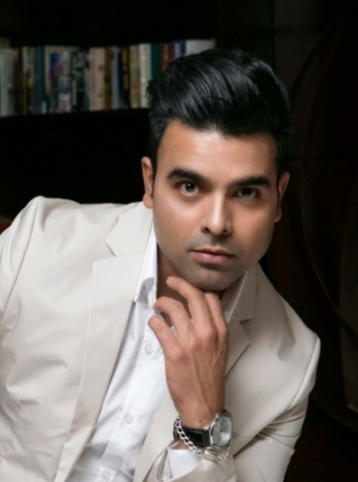
Manoj Marathe
Location: London (UK)
Height: 5’11” (180cm)
Weight: 171lbs (78kg)
Playing Age: 26-32 years
Actual Age: 33 years
Appearance: Indian, Middle East
Eye Colour: Black
Hair Colour: Light Black
Hair Length: Short
Chest: 40in (101cm)
Waist: 32in (81cm)
Voice Quality: Deep, Base, High Pitch (Can modify voice in squeaky)
Voice Character: Natural

Credits:
2018, upcoming short film ‘stolen ‘as a lead Actor.
2018, Upcoming Music video as a lead actor (Song: ‘Union Jack’)
2018, Bollywood stage show as a lead actor
2018, BT video as a Businessman with Mambo media
2018, Short video as a speaker with shape history
2017, TV commercial for LIDL
2017, Photo shoot & video shoot for lifestyle and Getty pictures
2017, Photo shoot for Xero online product
2017, Mr & Miss British Empire modelling show
2017, Shoot for Future now digital
2017, Mr & Miss Queen of Diversity competition
2017, Silk Road Fashion London Event
2017, Audition for Fashion show Catwalk model with CMM fashion
2017, Portfolio photo shoot with Model Advice mother agency
2017, Mr & Miss Queen of Diversity finalist Photo Shoot before Grand Finale
2017, Toxic Global modelling Show and Photo Shoot
2017, Model Advice Model Test Shoot
2017, Afro Model Award Show as a Catwalk Model
2017, Model Search UK Modelling competition- won the Title of Mr. Personality Model 2017
2016, Mr. British Isles Modelling competition contestant. As a Mr. Middlesex
2016, Photo Shoot for Toxic model agency
2016, Short Film music video ‘Upon My Skin’, as a lead role
2016, Shoot for Westminster College as a lead model with Caia Images for Library Shoot
2015, Shoot for crystal leisure centre London and boot camp modelling as a lead model
2015, corporate shoot for the online direct selling company Amway as a lead actor

Skills:

Accents and Dialects:
(*= native) Indian (Hindi)*

Languages:
(*=Native/Fluent) Hindi*, Urdu*, English*

Music and Dance:
(*=Highly Skilled) Bollywood Music*, Bollywood Dance*

Performance:
Drama Theatre, Voice Over, TV advertisement

Sports:
(*=Highly Skilled) Cricket*, Badminton, Running, yoga

Training: Mumbai Acting and Drama School 2004-2008

