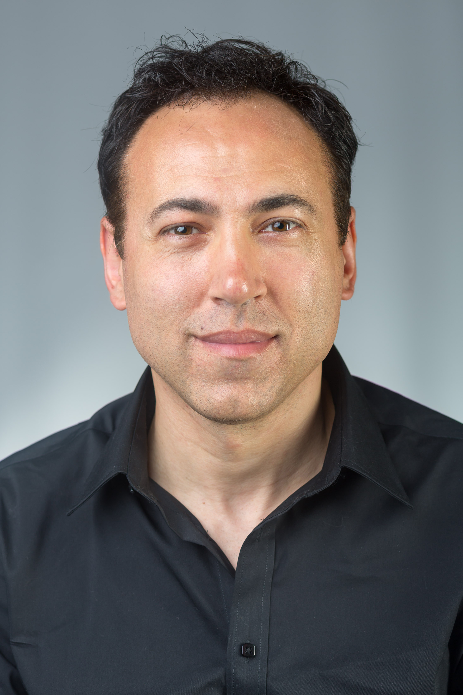 | Marco Mastrocola  Spotlight:  https://www.spotlight.com/interactive/cv/6050-4502-3166

Eyes: Brown Hair: Dark Brown Height: 6’0” (183cm)

Chest: 39” (99cm) Weight: 72kg Playing age: 34-49

Training
Richmond Drama School – Foundation in Acting (1991-1992)

Performance experience:

2018, Feature Film, Robert Nelson (Concertgoer), BOHEMIAN RHAPSODY, Tribeca Productions, GK Films
2018, Feature Film, David Jenkins, CHRISTOPHER ROBIN, Walt Disney Productions, Marc Forster
2018, Feature Film, Jeromy Doogie, JUDY, BBC Films, Rupert Goold
2018, Feature Film, Gilserfred Sneller, FANTASTIC BEASTS - THE CRIMES OF GRINDELWALD, Heyday Films, David Yates
2018, Television, Kevin Foster (Patient), HOLBY CITY, BBC, Donna Jackson
2018, Television, Josh Giddens (Nightclub), TURN UP CHARLIE, Netflix, Green Door Productions, Tristram Shapeero, Matt Lipsey
2018, Television, Yeoman, VANITY FAIR, Mammoth Screen, James Strong
2018, Television, Benjamin Edwards, WHITE GOLD (SERIES 2), Fudge Park Productions, Damon Beesley
1997, Stage, Nicholas Beckett, WHAT THE BUTLER SAW READ, The Crucible Theatre Sheffield, Michael Grandage
1995, Stage, Demetreus, A MIDSUMMERS NIGHT'S DREAM, The Octogon Theatre Bolton, Ian Forrest
1994, Stage, Jacobo, THE COUNT OF MONTE CRISTO, The Royal Exchange Theatre Manchester, Braham Murray
1993, Stage, Bassanio, THE MERCHANT OF VENICE, The Libary Theatre Company Manchester, Chris Honer

Additional skills: Musician (piano, Keyboards, guitar, Bass, Double Bass, Drums, Percussion)

