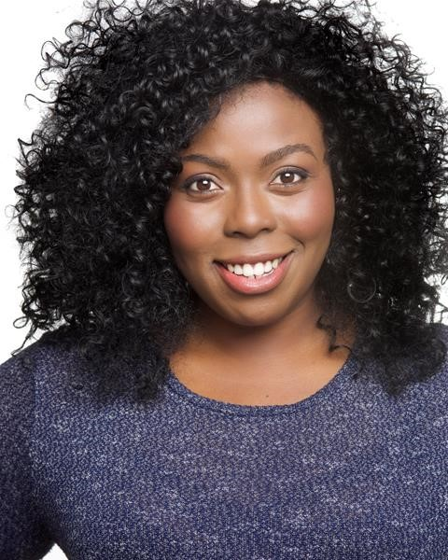
20 Medusa Road
London
SE6 4JW
Phone: 07714784869
Email: michellechantellehopewell@gmail.com Website:
Michelle Chantelle Hopewell
Photo: Claire Newman-Williams

Location:  Height:  Playing Age:  Appearance:  Other: | London, United Kingdom  5'4" (162cm)  16 - 25 years  Black-African, African-American, Black-Other  Areas  Equity | Eye Colour:  Hair Colour:  Hair Length:  Voice Character:  Voice Quality: | Brown  Black  Mid Length  Enthusiastic  Strong

Credits
2016, Musical, Attendant/Fortune Teller/Ensemble, Aladdin, Disney Theatricals, Casey Nicholaw
2015, Musical, Deloris Van Cartier, Sister Act, Gordon Craig Theatre, Catherine Lomax
2014, Pantomime, Chantelle, Miracle On 34 Parnie Street, Tron Theatre, Johnny McKnight
2015, Musical, Velma, West Side Story, Royal Conservatoire of Scotland, Andrew Panton
2015, Musical, John The Baptist, Godspell, Royal Conservatoire of Scotland, Andrew McGregor
2014, Workshop, Various, New Musical Development, National Theatre of Scotland, Laurie Sansom
2013, Musical, Ensemble, Betty Blue Eyes, Royal Conservatoire of Scotland, Dougie Irvine
2013, Short Film, Townperson, Sci-fiville, RCS Films, Michael Howell
2013, Television, Featured Soloist, Children in Need Scotland, BBC, Andrew Panton
Accents & Dialects: (* = native) African-West, American-African American, American-California, American-New York, American-Southern
States, American-Standard, Cockney, Estuary English*, Heightened RP, Jamaican, London, Manchester, Nigerian, Northern, RP, South
African
Languages: (* = Native/Fluent) English, Yoruba
Music & Dance: (* = highly skilled) Alto*, Ballad, Ballet, Blues, Contact Improvisation, Contemporary Dance, Contemporary Singing, Contralto*, Gospel Singing*, Jazz Dancing, Mezzo-Soprano, Piano, R & B Singing, Singer-Songwriter, Tap, Vocal Range: Low E (E below middle C) to top A
Performance: Actor-Musician, Actor-Singer, Musical Theatre, Poetry Reading, Singer-Professional
Sports: (* = highly skilled) Bowling, Pilates, Running, Swimming, Yoga
Other Skills: Computer Literate, Cooking/Baking, Hair Braiding, Improvisation, Knitting, Lyricist, Model-professional, Musical Theatre
Workshop Leader, Pilates, Story Telling, Writer
Training:
ROYAL CONSERVATOIRE OF SCOTLAND, BA Musical Theatre, 3 years, 2012 - 2015

