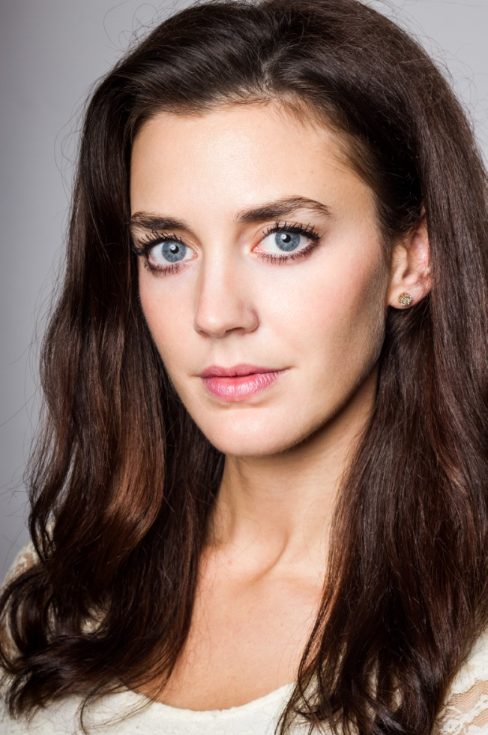

Title Role Director Production Company

*Television*

Strike Rosie Kieron Hawkes Bronte Film and TV

Buckingham Palace Kate Middleton Frances Beere Channel 5

Sketchpack Series 1 & 2 Various Jay Yip Wolfpack

*Film*

Girls Night Out Jeffers Pal Julian Jarrold Ecosse Films

Lovers Lane Frankie Ben Verrall Toffee Hammer

Writers Room Lucy Gabriel Gonzalez G59

Interview with a Hitman Angel Perry Bhandal Scanner Rhodes

*Commercial*

Whiskas Lead Ninian Duff Pulse

Tampax Lead Paul Thomas XFilm

Hellman’s Hero Joe Mayers Agile Films

Harvey Nichols Christmas Lead James Rouse Outsider

 07817 175091 [lucyfiona@hotmail.](mailto:lucyfiona@hotmail.com)[com](mailto:lucyfiona@hotmail.com)

*Lucy Scott-Smith*

Height: 5’7

Weight: 8st (112lbs)

Waist: 24”

Hips: 33”

Chest: 32C

Leg: 30”

## Eyes: Blue

## Hair: Dark Brown

## Playing Age: 25-35

Spotlight: 0279-1202-5199