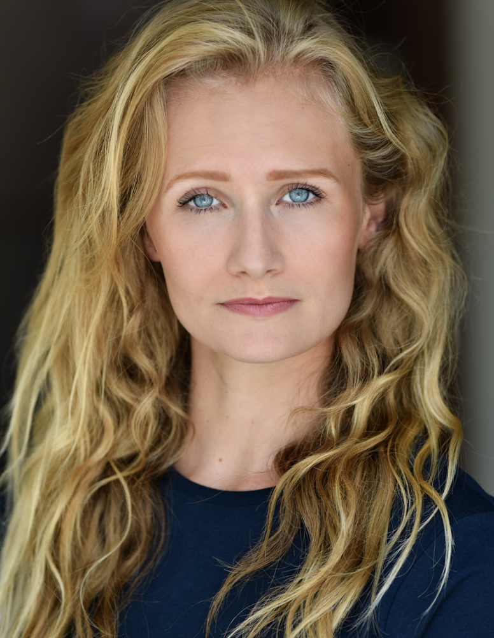

Personal Attributes
Hair - Blonde / Wavy
Eyes - Blue
Nationality - British
Skin - Fair
Height - 5’6
Dress Size - 8 / 10
Build - Slim / Athletic
Nicola Tee

TRAINING
Canterbury Christ Church University:
Vocal Studies, Singing, Acting
Dance - Hip Hop, Commercial. Basic Contemporary, Basic Ballet.

QUALIFICATIONS OTHER SKILLS
BA (Hons) Performing Arts Degree Stage Management
A Level Drama Driving Licence
A Level Film Studies Accents
BTEC Dance Diploma Grade 4 Piano
Running
Swimming
Basic Spanish

PROFESSIONAL WORK
Production Role Year Director
Muscat Festival 2018 - Oman Festival Dancer January 2018-February 2018 Daniela Forbes
The Show Performance Company Dancer November 2017-Present Tillie Smith
80’s On Show Singer June 2017- Present Jade Chamberlain
The Lipsticks Singer March 2017- December 2017 Joanna Fisher
Kylie On Show Singer/Dancer November 2016 - Present Jade Chamberlain
Various Shows Various Leads April 2016 - October 2016 Magda Piegtryga
Cinderella Pantomime Prince Charming December 2015 - January 2016 Philip Shaw
Screamland Event Deady McGee October 2015 Paul Howse
Let There Be Christmas Tour Singer December 2014 - January 2015 Alan Williams
Get Happy Show Guest Singer July - August 2014 Keith Simmons
Society Festival - France Dancer May 2014 Sophie Guariglia
Town Festival - Denmark Dancer September 2013 Sophie Guariglia
Get Happy Show Dancer July - August 2013 Keith Simmons

THEATRE CREDITS:
Production Role Year Director
What Could Have Been Lead 2015 Patricia Bajakova
PPA Live 2014 Dancer 2014 Sophie Guariglia
Strings Attached Actor 2014 Nicola Tapsell
Witches of Eastwick Gina 2014 Max Reynolds
Mamma Mia! Sophie 2011 Kerry Blaskett

TV CREDITS:
Programme Role Year Channel Aired
Mamma Mia! 2 Air Hostess 2017 Various
Thanks For The Memories Stand-in (Tamzin Merchant) 2017 Various
The Crown - Series 2 Mandy Rice-Davies 2017 Netflix
The Tunnel - Season 3 Waitress 2017 ITV
The Windsors Christmas Special Extra 2016 Channel 4
‘Get Down’ - Music Video Dancer 2016 Various
Head and Shoulders - Advert Extra 2016 Various
Romans - Film Extra 2015 Various
The Martian - Film Extra 2015 Various
Guitar Heroes - Game Extra 2015 N/A

