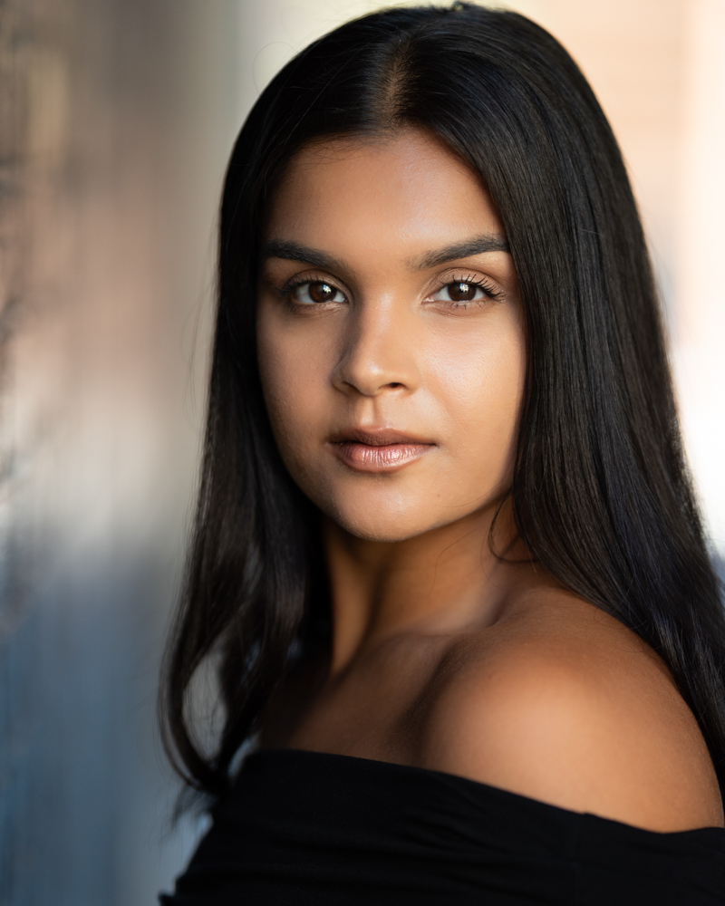
Preeti Sian
Ethnic Origin: British Indian
Hair colour: Black
Eye colour: Dark Brown
Measurements
Height: 5ft 7” Waist: 28” Dress size: 8/10
Hips: 35” Bust: 32” Shoe size: 6
Training: Tiffany Theatre College (2013 – 2016) - Performing Arts
Skills: Commercial, Jazz, Hip Hop, Contemporary, Locking, Freestyle, Latin, House, Vogue, Waacking, Bollywood, Bhangra, Partner work, Camera work, Contemporary/Musical Theatre singing, Acting.
Other skills: Full UK driving license, swimming, aerobics, roller skating, ice skating, running, athletics, yoga, pilates, cooking, trampolining.
Credits:
- Dancer/Model, GHD Hair Social Media Campaign
- Dancer, Television, Sky One, ALAN CARR “THERE’S SOMETHING ABOUT MOVIES”
- Dancer, BOLLYWOOD FILM, Bhangra Paa Le, Naila Mughal Castings
- Dancer, Underwraps Choreography, GLOBAL VILLAGE, DUBAI
- Dancer, Buddha Bar, Marrakech, Morocco, SERENDIPITY CASTINGS
- Event, Dancer, JD SPORTS
- Event, Dancer/Model, INTERSPORT FASHION, Arthur Gourounlian
- Commercial, Actress, SONY PLAY LINK
- Commercial, Dancer/Actress, EE IPHONE & APPLE WATCH, Hank Perlman
- Commercial, Dancer, LEVIS, Cherry Films, Jake Nava
- Commercial, Actress, ABOTT PHARMACEUTICALS
- Music Video, Dancer, MUSIC VIDEO, Arthur Gourounlian
- Television, Dancer, CHANNEL 4 “THE LAST LEG”
- Dancer, JD SPORTS PUMA COLLECTION
- Dancer/Model, PAUL MITCHELL HAIR

