Poppy Lawless
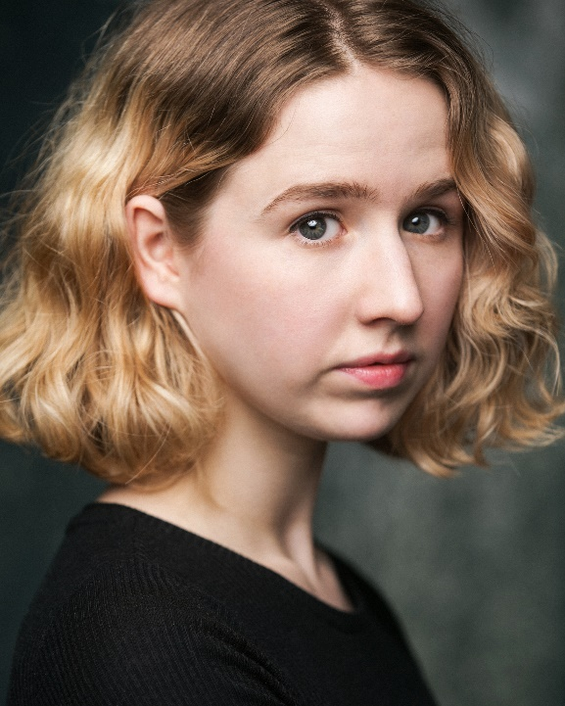

British
04/05/1990
16-25
5'4"
Slim

Credits
Year | Role/Type | Name of production/  Director | Company/Venue
2018 | Dries Van Noten Model  Stills Shoot | W Magazine/ Director: Sara Moonves, Photographer: Sam Rock | W magazine/ Laura Holmes Production
2017-2018 | Fanny | Hope Is waking | Out of ideas  Drayton Arms Theatre/ Earls Court
2017 | Librarian Girl | Revlon Commercial USA | Revlon
2017 | Chris O’dell  TV | Break Up Of The Bands- The Beatles | ITV
2017 | Jumping Girl Commercial still | Thomas Cook Still Shoot | The Forge Photographic/ Thomas Cook
2017 | Sarah's Double | Amit Gupta | Gate television productions
2017 | Café Girl | Sony Commercial
2017 | Courtier | The Favourite  Yorgos Lanthimos | Element Pictures
2017 | Poppy  Film (Short) | FIN  Savanah Leaf | Independent  Girls in film
2016 | Betty  Film (Short) | Sectioned  Taz Ayoub | Actors Studio/Pinewood Studios
2016 | Annie  Film (Short) | After The Fire  Taz Ayoub | Actors Studio/Pinewood Studios
2016 | Trainee Nurse  Corporate | Wellpets revisited  Brittany Woodhall | Groundbreak  Productions
2016 | Crying Girl  Commercial | Mean onions/The British Leek Society | One Small Pixel
2016 | Trainee Nurse  Corporate | Wellpets  Brittany Woodhall | Groundbreak Productions
2016 | Sarah | Curse  Greg Mandry | Big Yellow Feet
2015 | Gigi | Mel Churcher  Short Film | Pinewood Studios
2015 | Costume Girl | Mel Churcher  Short Film | Pinewood Studios

Training
Year | Qualification | Where
2016 | Meisner Technique | Actors Temple
2016 | Acting For film  Mel Churcher | Pinewood Studios

Showreel Link:
https://actors.mandy.com/uk/actor/profile/poppy-lawless-1

