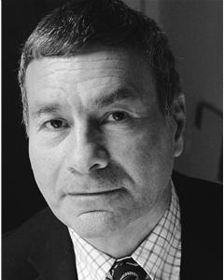
RALPH BERKLEY

Location: London
Height: 5'7" (170cm)
Weight: 11st. (70kg)
Playing Age: 41 - 55 years
Appearance: Eastern European, White
Other: Equity
Eye Colour: Brown
Hair Colour: Dark Brown
Hair Length: Mid Length
Credits:
2007, Corporate, Irish Businessman/customer in Pharmacy, ROLE PLAY FOR COLGATE
2006, Radio, Singer/Look A Like Columbo, INTERVIEW WITH BBC RADIO ESSEX
2004, Event, LOOK A LIKE DETECTIVE COLUMBO, London Hotel
2003, Commercial, Embarrassed Father, TALK PRO GOLF
2002, Television, Mr. Sparks (Lead Role), CBBC EDUCATION, BBC Television, Helen Chase
2000, Feature Film, Thomas Hooker, PURE FREEDOM, Marshall Productions, Richard Elson
1999, Commercial, Customer/Feature, ICELAND
1998, Short Film, Lester, CHICKEN, NFTS Beaconfield, Tom Shankland
1996, Commercial, Mexican, ANDREWS LIVER SALTS
1996, Feature Film, Businessman, ELECTRIC VENICE, L.I.F.S, Craig Gailbraith
1995, Feature Film, Shady Bookie, COMEUPPANCE, L.I.F.S, Dominic Osbourne
1995, Television, Fred West, NEWSNIGHT, BBC Television
1995, Video, Long John Silver, LONG JOHN SILVER
1994, Video, Opera Loving Happy Postman, HAPPY POSTMAN, European Script Fund
1990, Feature Film, Drunken Bondwinner, YOU CAN'T TAKE IT WITH YOU, London International Film Sch, Jeremy De Cocq
1988, Television, Teaker The Butler, HANNAY, Thames Television, Ken Hannan
Skills:
Accents & Dialects:
(* = native) Cockney, Essex, London*, South African*
Languages:
(* = Native/Fluent) English*
Music & Dance:
(* = highly skilled) Ballad*, Cabaret Singing*, High Baritone
Vehicle Licences: Car Driving Licence

