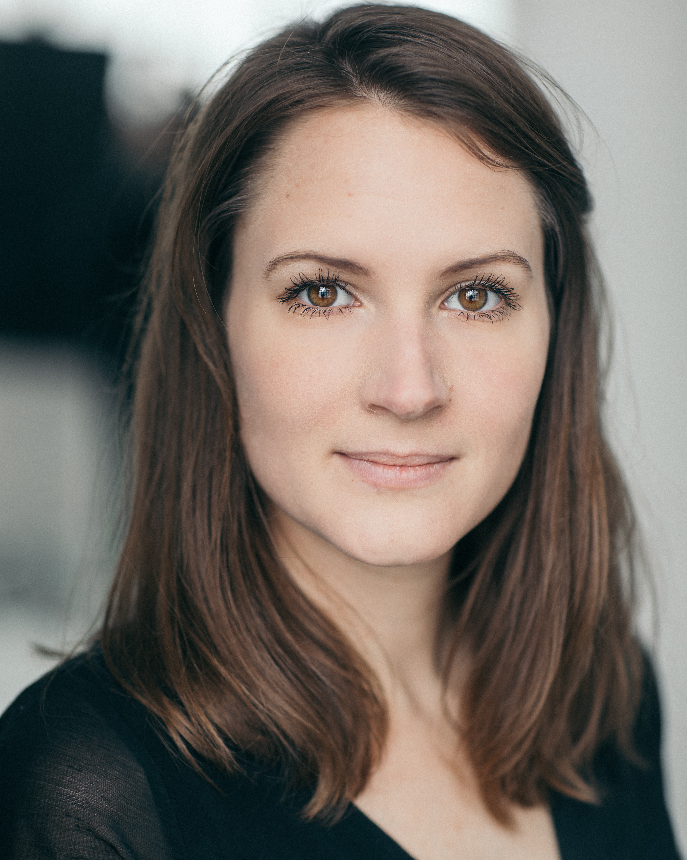
REBECCA TENOR
07946383630 | rebeccatenor@hotmail.com

HEIGHT | 5’9” (174CM) | HAIR | BROWN
BUILD | SLIM | EYES | LIGHT BROWN
PLAYING AGE | 20-30 YEARS

//TRAINING | 2012-2016 BA (HONS) ACTING – KADA  2007-2010 St Eriks Gymnasium Theatre (Acting)

// CREDITS
ROLE | PRODUCTION | DIRECTOR
Hedda Gabler  Katherine | HEDDA GABLER  (Sofa Productions)  THE WAKE OF JAMEY FOSTER  (Sofa Productions) | Emma Johansson  Louise Moberg
Karen | AUGUST: OSAGE COUNTY  (Sofa Productions) | Paul Mushumani
Philipa | A MURDER IS ANNOUNCED  (Sofa Productions | Katy Dower

/ / FURTHER CREDITS
ROLE | PRODUCTION | DIRECTOR
Amelia  Betty Mouse | FRIGHT NIGHTS  (Sofa Productions)  ONCE UPON A TIME  (Sofa Productions) | Sarah Moon  Nicola Higgins
Miss Fyce | FROM RUSSIA WITH LAUGH  (Sofa Productions) | Madeleine Meurman

/ / FILM, TV & RADIO WORK
ROLE | PRODUCTION | DIRECTOR
Mother BabyStyle – iSite TV Jack Stimson
Lucky Promo - Flight Club Joseph Patrick
Deborah Love Hurts Caleb
Brides maid Train App – Rail Delivery Group Jai Rafferty
Friend Der Kommissar und das Meer Thomas Roth
- Der tod Kam am Nachmittag

/ / SKILLS
ACCENTS & DIALECTS (*=native) | English-Standard, American-General, American-Southern, Scandinavian
LANGUAGES (*=mother tongue) | English, Swedish*, French (Basic)
MUSIC & DANCE | Singing: Alto, Guitar (medium), Ballet (basic), Lindy hop (basic), Jazz
PERFORMANCE | BASSC certificate Rapier & Dagger and Unarmed combat
SPORTS (*=highly skilled) | Yoga*, Skiing, Aerial Silk
OTHER | Driver’s License, Improvisation, Physical Theatre, Alexander Technique

