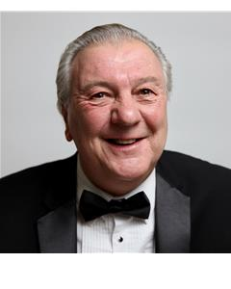
STEPHEN BERKELEY

Location: London
Height: 5'10" (177cm)
Playing Age: 61 - 70 years
Appearance: Scandinavian, White
Eye Colour: Hazel
Hair Colour: Greying
Hair Length: Mid Length
Voice Character: Friendly
Voice Quality: Warm

Credits:
Previous experience in Repertory Theatre, London Fringe, Tours and Circus. Has also worked extensively in the training & presentation of Dolphins, Sealions, Parrots and various other animals.

Credits
2015, Film, Father John, FEARS, MW FILMS INC, Gary Wasniewski
2014, Television, Hitler, RISE OF THE NAZIS, Worldwide Media - Discovery Channel, Matthew Hinchcliffe
2014, Feature Film, Gary Snider, THE NEWSPAPER, Jordan Kensington
2013, Television, Benefit Fraudster, SAINTS & SCOUDRELS (DRAMA RECONSTRUCTION), BBC
2013, Feature Film, Hot Potato Seller, MUPPET FILM 2
Commercial, Young Saver, ANGLIA BUILDING SOCIETY, Moving Picture Company, Grahame Baker
Commercial, Man at Party, BREAKER MALT LIQUEUR, Moving Picture Company
Commercial, Drinker at Bar, BREW TEN, Moving Picture Company, Grahame Baker
Film, Lead Villian, CROSSED LINES, BBC
Television, Person in Bar, ROADS TO FREEDOM, BBC Television
Television, Small Part, SOFTLY SOFTLY, BBC Television
Television, Market Trader, Z CARS, BBC Television

Skills:
Accents & Dialects:
(* = native) Lancashire, London
Training:
Drama, Manchester University. City Lits, drama workshops with Dorathea Alexandra.

