Tony Pankhurst

SPOTLIGHT VIEW PIN: 4777-9054-3051

Website: www.tonypankhurst.com

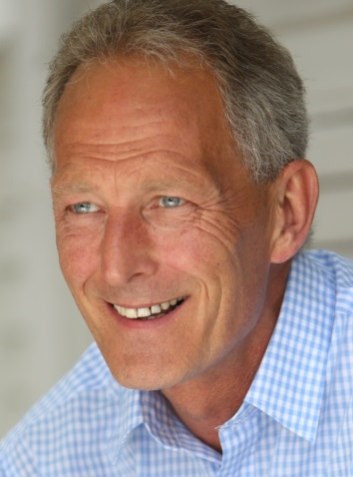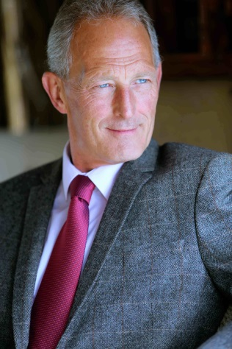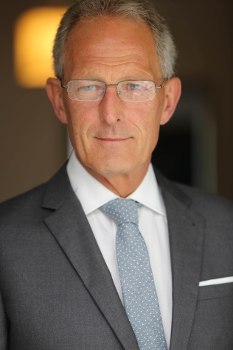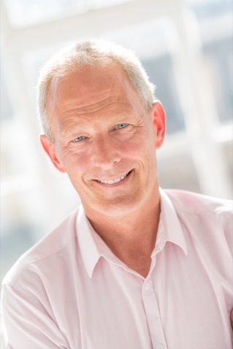
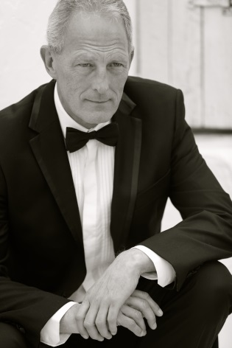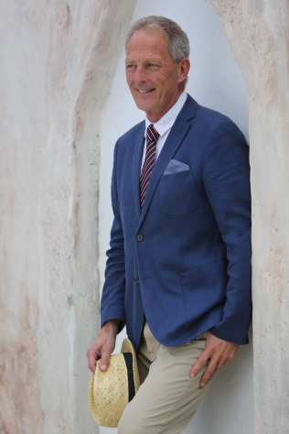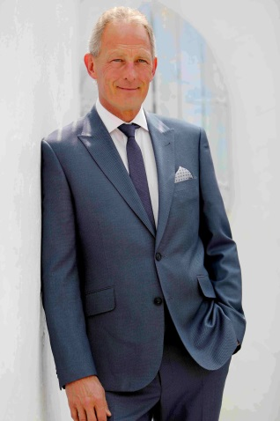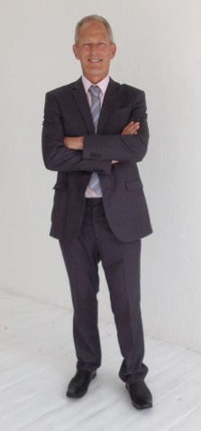

SKILLS AND APPEARANCE
PLAYING AGE: 55 – 60 APPEARANCE: White, Caucasian
HEIGHT: 178 cm / 5ft 10in WAIST: 88 cm / 34in
WEIGHT: 85 kg / 187 lbs SHOE SIZE: 10.5 UK / 11.5 US / 45.0 Euro
ETHNICITY: White / Caucasian HAIR COLOUR: Salt and Pepper
SKIN COLOUR: Tanned HAIR LENGTH: Short
HAIR TYPE: Curly EYE COLOUR: Blue
CHEST SIZE: 106 cm / 42 in ACCENTS: Sussex (Native), London, Cockney, Essex

SPOTLIGHT PIN: 4777-9054-3051

Full profile, audio samples, additional photos and show reels can be seen at:

SPOTLIGHT PROFILE: http://www.spotlight.com/interactive/cv/4777-9054-3051

ACTING SHOW REEL: www.youtube.com/watch?v=bSGHh-s2i6A

PRESENTER SHOW REEL: www.youtube.com/watch?v=WXooJUnlBWY

PHOTOS AND FULL PROFILE: please visit: http://tonypankhurst.com/

VOICEOVER CLIPS: http://tonypankhurst.com/audio-clips/
EXPERIENCE

Television:

2018 EASTENDERS – Passenger on Ferry to France
2017 TRAUMA (ITV) – Doctor/Surgeon
2017 THE CHILD IN TIME (BBC) - Mourner
2017 IN DARKNESS – Restaurant Customer
2017 THE ROYALS 3 – Auction Bidder
2017 EASTENDERS – Café customer (Featured)
2017 LUCKY MAN 2 – Dining Guest
2016 APPLE TREE YARD - Scientist
2016 EASTENDERS. Featured role of Hospital Doctor
2016 THE ROYALS. Featured role of Audience Member
2016 THE NEGOTIATORS (Pilot) Role of Ex president Bill Clinton stand-in
2016 COUNT ARTHUR STRONG SERIES 3. Public Gallery spectator court scene
2016 UNDERCOVER (BBC1) featured Party Guest
2016 SILENT WITNESS 19 (BBC1) featured role John Wyant Doctor
2015 WALLIAMS AND FRIENDS (BBC1) Featured role David Walliams Xmas party friend
2015 HOLBY CITY (BBC1) Featured role Holby NHS Trust board member
2015 EASTENDERS (BBC1) Featured role Manager of a Mens Outfitters
2015 BIRDS OF A FEATHER Dorians birthday party guest
2015 TRACEY ULLMAN SHOW featured role of Hotel Concierge
2015 THE CROWN (NETFLIX) Multiple Episodes Featured role Buckingham Palace footman
2015 LOVE ISLAND (ITV2) TV Ident
2015 DOWNTON ABBEY (ITV) featured role of Bookmaker
2015 The TUNNEL (SKY ATLANTIC) Featured role SOCO
2015 UNFORGOTTEN (ITV) Featured Role of Forensic Scientist
2015 THE LAST PANTHERS (SKY) Role of Corporate Guest
2015 LUCKY MAN (SKY). Featured Role of Bookmaker
2015 THE TUNNEL SERIES 2 (SKY). Featured Role of Soco at Murder Scene
2015 ENDEAVOUR 3 (ITV). Featured Role of Gambler
2015 THE DRESSER (BBC 2). Role of Audience Member
2015 EASTENDERS (BBC 1) Featured Role of Posh Diner
2015 HOLBY CITY (BBC 1). Featured Role of Neurosurgeon
2015 NEW TRICKS (BBC 1). Featured Role of City Trader
2015 LONDONGRAD (Russian TV) Featured Role of Double for lead actor
2015 HUMANS – Featured Role of Husband to a synthetic robotic wife
2015 RIVER (BBC 1) Featured Role of Restaurant Guest
2015 VISCIOUS (ITV 1) Role of Mature Fitness Instructor
2015 ARTHUR AND GEORGE Role of Uniformed Police Officer
2014 YOU ME AND THEM (Sky) Role of Posh Restaurant Guest
2014 QVC PROMO (Sony TV) Featured Role of Husband
2014 BABYLON (CHANNEL 5) Role of Armed Police Officer
2014 THE GO BETWEEN (BBC 1) Featured Role of 1920`s Rail Station Porter
2014 THE ROYALS (E4) Featured Role of Paparazzi (Speaking)
2014 THE INTERCEPTOR (BBC 1) : Henry Adam Airline Passenger
2014 SUSPECTS (CHANNEL 5) Duty Solicitor
2014 VALENTINES KISS (TV Drama) : Featured role of Lord Rupert Mallory dinner guest
2014 24: LIVE ANOTHER DAY.(SKY 1) Foreign Office Dignatory
2014 CRITICAL (SKY 1) : Role of Resus Patient
2014 EASTENDERS (BBC1) : Peter James Walford Councillor (speaking)
2014 SUSPECTS (Channel 5) Solicitor with Ray Fearon and Faye Ripley
2014 ENDEAVOUR 2 (Trove) - (ITV 1) : Mr Dawson Hotel Guest
2014 CHRISSY B TV Chat Show (SKY) : Guest on Chrissy B Chat show
2013 PROJECT X. (ITV Promo now Commissioned) Tony Beresford Businessman (Speaking).
2013 BRITAIN`S EMPTY HOMES (BBC 1) : Featured role. Current Series - Episode 5
2013 SILK (BBC 1) – Customer in Pub and Passer-by. Series 3 Episode 6
2013 POWER TO THE PEOPLE (TV sitcom Pilot) with comedian Danny Dyer (Episode 6)
2013 DOWNTON ABBEY (ITV) – Member of Royal Court (Carnival Productions)
2013 DOWNTON ABBEY (ITV) – Distinguished Guest at Royal Gala Xmas Day Special Episode
2013 FOR THE LOVE OF ELLA (TV Pilot) Comedy Series – Support Artist
2013 POINTLESS (BBC 1) Quiz Show (Contestant)
2013 NEW TRICKS (BBC 1) – Police Officer

Film:

2018 3 LATERAL COMPUTER GAME – Main Character for computer game (Filmed in Serbia)
2017 ELECTRIC DREAMS – Hand Double for Timothy Spall
2017 HOLMES AND WATSON – Upper Class Victorian Gentleman
2016 THE COMMUTER – Featured subway passenger
2016 JAZZ MOCUMENTARY ANDY DAVIES TRUMPETER (Pilot) featured role of Jazz Club Manager
2016 FANTASTIC BEASTS AND WHERE TO FIND THEM (Role cannot be disclosed for NDA purposes)
2015 WAR MACHINE role of Conference guest
2015 STAR WARS – ROGUE ONE Featured role Marine Council General
2015 RISE OF THE KRAYS – Featured Role of Fisherman dragging dead body into sea
2015 1603 – Role of Church Mourner
2014 MISSION IMPOSSIBLE 5 – Featured role CIA Agent
2014 STAR WARS - FORCE AWAKENS – Harrison Ford (Hans Solo) STAND-IN ROLE
2014 MR HOLMES (Slight Trick Of The Mind) : Police Sargeant
2014 LEGEND Casino guest of Reggie Kray
2014 ABSOLUTELY ANYTHING. Role of Father
2014 LONDON ROAD. Peter Wright QC Barrister
2014 BREAKING THE BANK (Universal Pictures) – City Banker/Investor
2013 THREE DAYS – Bookshop customer
2013 PEARLS OF AFRICA - Boardroom member corporate company.
2013 THE THEORY OF EVERYTHING. Christening Friend of Professor Stephen Hawking
2013 BABYLON – New York Police Chief with James Nesbit (stills) (Channel 5)
2013 THE ELEVATOR PITCH – Head Juror (Speaking Role)
2013 SCHWARZWALD – Pub customer
2013 HARRY HILL THE MOVIE – Heckler

TV Commercial:

2018 BIRDS EYE INSPIRATIONS – Channel 5 TV ident for Birds Eye
2018 STUDIO 90 FISHPOOLS FURNITURE – Model for furniture range brochure and TV Advert
2017 CONFUSED.COM Retired Husband Car Driver
2017 NESPRESSO. Stand-in for George Clooney
2017 HEALTH LOTTERY. Role of Shopkeeper
2016 NATIONAL EXPRESS COACHES. Couple travelling on coach journey.
2016 FIRST DATES (CHANNEL 4) THOMSON IDENTS. (Tenerife). Couple on holiday
2015 QUAKER OATS Role of farmer
2015 PARK HOLIDAYS TV Brochure and Online Couple on Holiday
2015 BETWAY Betting customer at Tennis and Cricket event
2015 GOODNIGHT ANTI-SNORING RING customer talking about product
2015 TOUCH OF SILVER SHAMPOO (PRO-VOKE). Customer using product
2015 WARNER LEISURE HOTELS TV Brochure and Online Couple on Holiday
2015 FERRERO ROCHER. Stills and Video. Party Host
2015 PAN BAHAR (India) - Stills, Video, TVC. Husband
2014 KIMS PRIVATE HOSPITAL. John Hare Post Op Patient
2013 BELVEDERE CLINIC. Consultant Surgeon
2013 CLARIVU LASER EYE CARE. Consultant with Ruth Langsford
Visit: http://www.optegra.com/vision-correction/clarivu#ruth
2013 JML GROUP. Product Demonstration of HALOWAVE COOKER (Infomercial)

Corporate:

2017 POST OFFICE - Role of Scammer for Money Laundering Training film (speaking lead)
2016 RECOMBU Comedy spoof for mobile phone advert
2014 HARRY POTTER TOUR Role of Businessman Corporate photos and web
2014 LENZ & STAEHELIN SWISS LAW. City Client
2014 GE CAPITAL COMMERCIAL FINANCE. City Invester
2014 BIOMET. Uber Digital : Patient in Pain, London, UK, London, UK
2014 JOHNSON CONTROL. Role of visiting businessman (speaking), Aldershot, Hants, UK
2014 GECKOBOARD. Role of Businessman/Company Owner (speaking), London, UK

Modelling:

2018 UBS LTD – Stills for keeping fit and wellbeing for UBS employees
2018 UNIVERSAL UK TV – Launch for The Resident TV Drama role of Surgeon for Billboards/Posters
2018 SANOFI MEDICAL – Vaccine video and brochure
2018 RENTOKIL INITIAL – Role of Scientist in laboratory inspecting bugs
2018 HOPPY EXPLAINER APP (EDF ENERGY) – Customer using the new Hoppy App
2018 DEAR DEIDRE (The Sun) – Husband of wife having affair
2018 RUIT LUGGAGE – Modelling for range of Rucksacks and Backpacks
2018 STUDIO 90 FISHPOOLS FURNITURE – Model for furniture range brochure and TV Advert
2018 CELLO HEALTH INSIGHTS – Patient for Heart drug
2017 HAVEN HOLIDAYS – Holiday guest for brochure and online
2017 TRAFALGAR TRAVCORP – Holidaymaker Hidden Gems Tour London
2017 TRAFALGAR TOURS – Holidaymaker Touring France
2017 SAGA HOLIDAYS – Husband on Holiday Tour
2017 BT (4G PHONES) – featured Business Commuter
2017 TRAFALGAR TRAVEL – Shoot in Geneva holiday brochures
2017 JAGUAR/LAND ROVER – Senior Technician Tutor
2017 CELGENE BIOPHARMA – Featured Patient
2017 HCA HEALTHCARE – featured Patient
2017 CAIA IMAGES : Grandad with grandchildren family shoot
2017 AMAZON APP – featured Dentist and Gardner roles
2017 PHILIPS HEALTHCARE : featured Patient
2016 MCCGLC LTD. Role of Patient suffering from Glaucoma. Video and Stills (Speaking)
2016 JOHNSTONES DECORATING CENTRES (MIDLANDS) Role of DIY Store Manager
2016 JANIE AIREY Library shoot Senior Dating
2016 RICK DOWNER SECURITY. Role of CEO with Security/Bodyguard
2016 ONE HOUSING ASSOCIATION Care Home resident
2016 COPD (chronic obstructive pulmonary disease) Client: Confidetial. Patient receiving treatment
2015 CHELSEA OUTPATIENT CENTRE Patient for Advanced screening
2015 WAILING BANSHEE LIFESTYLE Various businessman scenes. Brochure stills and Online
2015 THOMSON REUTERS FINANCIAL Role of Lawyer. Brochure stills and Online
2015 BEECHCROFT CORPORATION Role of retired man in care home. Online
2015 VISIT BRITAIN Holidaymaker visiting iconic places in Britain. Brochure stills and Online
2015 MOTORPOINT CAR SHOWROOMS Part of couple buying a car. Brochure stills and Online
2015 HARRY POTTER WARNER BROTHERS TOUR Brochure stills and Online Corporate Guest
2015 KYLIE MINOGUE MARRY ME Stills shoot for Best Magazine article
2015 HOLIDAY EXTRAS LTD. Stills and online video. Comedy role for Insurance products
2015 ARSENAL FOOTBALL CLUB. Stills for Corporate Dining. Diner
2014 FREESTYLE HEALTHCARE PHARMACEUTICAL. Stills for Brochure. Mature Gentleman
2014 QVC – Fuji Camera launch stills
2014 VOYAGES OF DISCOVERY (Cruise Around Mediterranean) - Cruise stills and video
2014 HARRY POTTER CORPORATE TOUR (Warner Brothers) - Stills
2014 QVC - Sony TV Stills, Video
2014 LEWIN HALL PRODUCTIONS - Corporate Stills, Video
2014 L & S LAW - Corporate Stills, Video
2014 KIMS PRIVATE HOSPITAL - Stills, Video, TVC
2014 GE CAPITAL - Corporate Stills, Video
2014 TECHTV - Corporate Stills
2014 BIOMET VANGUARD - Stills, Video
2014 BELVEDERE COSMETIC SURGERY - Stills, Video, TVC
2013 GROWTH FIRESTARTER - Corporate Stills
2013 CLARIVU OPTEGRA - Stills, Video,TVC
2013 JML DIRECT - Stills,Video,TVC
2013 GEEMARC HEARING AIDS – Stills

Presenting: (Radio, TV and Video)

2018 HOPPY EXPLAINER APP (EDF ENERGY) – Customer using the new Hoppy App (Dialogue)

2016 MCCGLC LTD. Role of Patient suffering from Glaucoma. Video and Stills (Dialogue)

2016 MEDICAL LEASE EXCHANGE (SYS) Presentation video for Medical products (Autocue)

2015 MOBILE WORLD CONGRESS (Barcelona) – Interviewing exhibition guests, exhibitors, CEO`s, CTO`s and experts in the mobile phone industry. Presenting new products. (Dialogue)

ARROW FM (Commercial Radio Sussex). Presenting a 4 hour live sports show on Saturday. Presenting a 2 hour live phone-in show on Sunday with guests, competitions and interviews.

BBC SUSSEX (Radio). Freelance duties, presenting, interviewing, vox pops and script producing and editing.

OTHER:

2014 MILLIONAIRE Episode 5 and 7 (Smithsonian Institute USA). Documentary Role of Bill Bowerman Co-founder of NIKE

Previous Work: (Pre 2009)
Previously an extra, support and stand-in pre 2009 for many years but then took a break until late 2012, as my wife suffered a brain haemorrhage in 2009. Pre 2009 extras, support and stand-in work included:

World Cup stories (BBC)
Time after Time (Car salesman)
Fosters Lager Ad, (Customer at Bar)
Hotel Babylon (Hotel guest)
Vicar of Dibley (Congregation)
Mutual Friends (court scene police officer)
Criminal Justice (Police officer)
Bone Kickers (archaeologist non speaking) ………And numerous others.
2003 Guest - Kilroy Talk Show BBC TV (3 separate appearances)
1998 Guest – Michael Cole Talk Show SKY TV (2 separate appearances)
1997 Featured Subject – Noels House Party NTV Subject Noel Edmonds BBC TV

Radio:
2013 Producer Presenter Editor - National Talking Newspapers and Magazines (RNIB) 2013
2012 Producer Presenter Editor - National Talking Newspapers and Magazines (RNIB) 2012
2010 Producer Presenter Editor - Hastings Local Radio 2010 – 2012
2000 Presenter - Freelance (5 years)
2000 Presenter - Breakfast Show Arrow FM (Stand-in 1 year)
2000 Presenter - Saturday Sport Arrow FM (2 years)
1986 Guest – John Dunn Show BBC Radio 2
1978 Guest – Pete Murray Show BBC Radio 2

OTHER INFORMATION:
Full profile, audio samples and additional photos can be seen at:

SPOTLIGHT PROFILE: http://www.spotlight.com/interactive/cv/4777-9054-3051

ACTING SHOW REEL: www.youtube.com/watch?v=bSGHh-s2i6A

PRESENTER SHOW REEL: www.youtube.com/watch?v=WXooJUnlBWY

PHOTOS AND FULL PROFILE: please visit: http://tonypankhurst.com/

VOICEOVER CLIPS: http://tonypankhurst.com/audio-clips/

