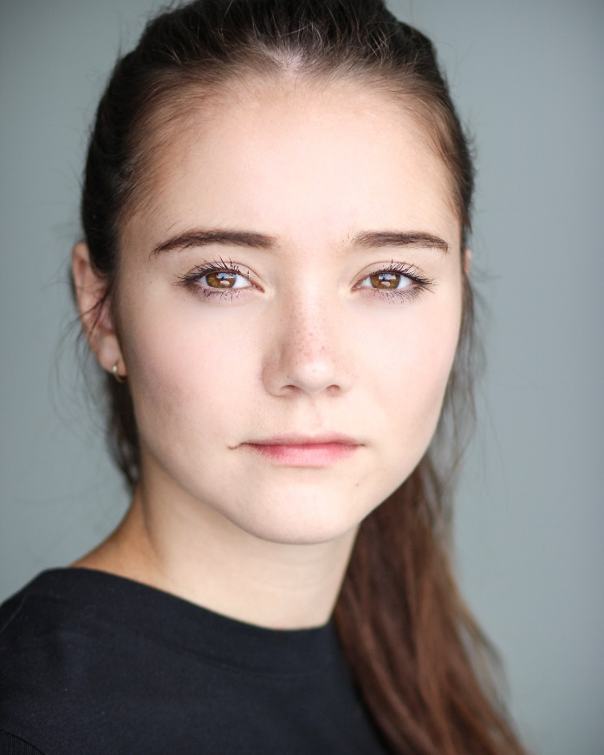
Zoe Meningen

Height: 5’6
Build: Slim
Hair: Brown
Hair Length: Long
Eyes: Brown
Playing Age: 16-24

Spotlight Pin: 5495-7863-4323

Location: London, UK

Credits:
2018, Short film, Lucy, LEADER, Holepunch Pictures, Aidan Sheridan
2018, Short film, Nell, A WARNING, Holepunch Pictures, Aidan Sheridan
2018, Short film, Lucy, CUBICLE, Holepunch Pictures, Aidan Sheridan
2017, Theatre, Samuels, LANDMINES, The Bridge Theatre Company, Emma Higham
2016, Theatre, Jenny, YEN, Trafalgar Studios, Ben Matthews
2016, Theatre, Rain, UNHAPPY TRUTHS, Nox Theatre
2016, Theatre, Elizabeth Proctor, THE CRUCIBLE, Common Ground, Stuart Worden
2015, Theatre, Lucy, LIES IN THE SKIES, New Wimbledon Theatre, Eloise Jeary
2015, Theatre, Charles VI, HENRY V, RSC & Brighton Fringe Festival, Simon Stephens
2014, Television, Sam Smith backing vocalist, THE X FACTOR FINAL, ITV
Skills:
Accents & Dialects: Estuary*, RP, London, Cockney, Essex, Liverpool, Yorkshire, General Scottish, General Welsh, American – Standard, American – Californian, American – Southern States, South African, New Zealand, Australian
Languages: English
Music & dance: Alto, Pop singing, Chorus
Sports: Horse Riding, Swimming, Running, Fitness
Other Skills: Painting, Drawing, Baking, Vehicle License
Training:
BRIT School for Performing Arts and Technology, Acting, 3 years 2014-2017

