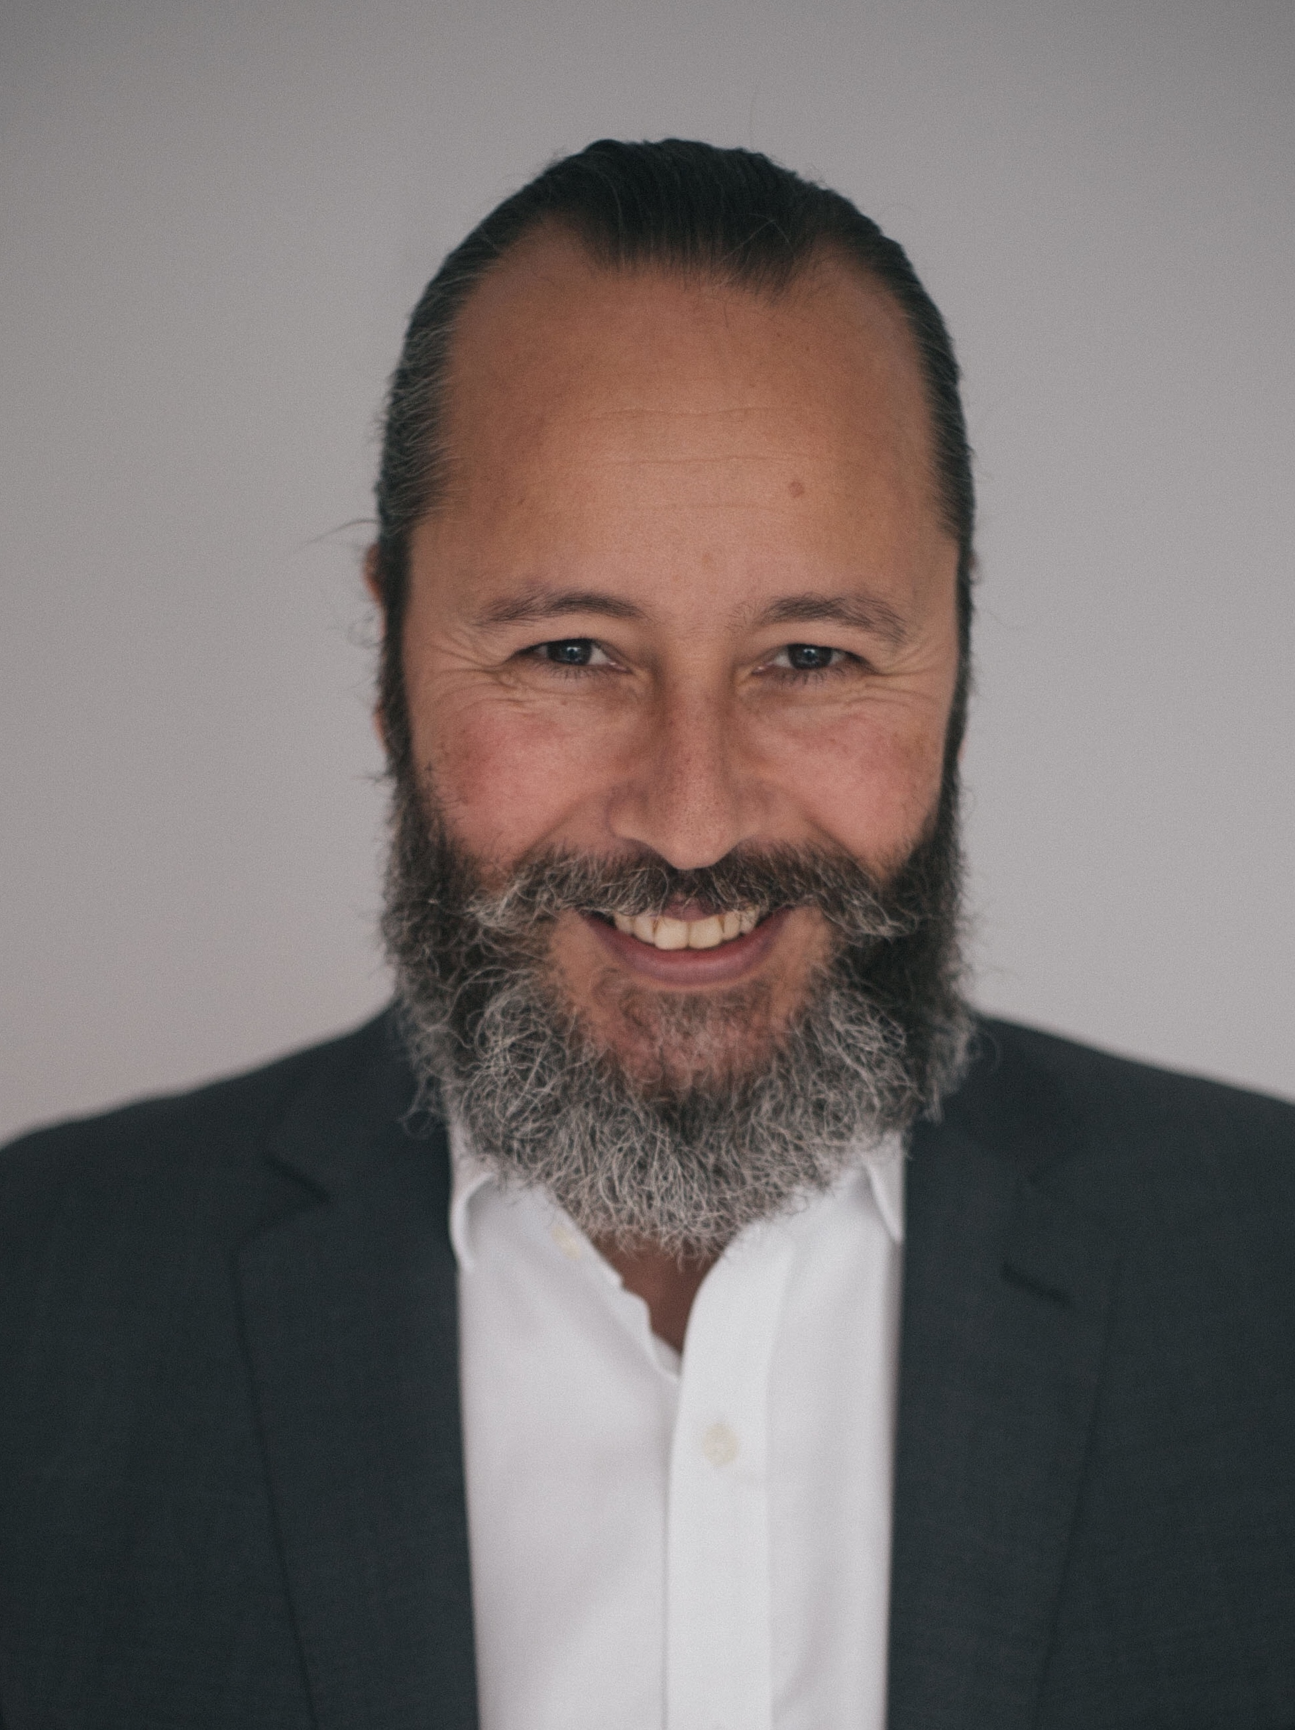
Robert F McCrea M.I.O.D.

Contact Direct: 01227 904977
07786917333

Email: Robert.mccrea@icloud.com

Equity Member: M00145476

Spotlight Member 4138-9054-1280

Personal Details

D.O.B. 05/06/1968 Height 5.11’ Chest: 43 Waist: 36 Inside leg: 31

Eyes: Brown/black Hair: Wavy Build: Stocky Playing Age: 40yrs to 55 yrs
(brown/grey)

Training
Naturalistic and dynamic acting | Declan Donellan | November 1993
Physical Expression and mime | Phillip Glass | May 1993
Physical Theatre | The Right Size | April 1993
3-Year BA Hons. Dramatic Art | Bretton Hall | 1986 to 1989

Film and Television Experience (as an actor)

Year | Role | Production | Director | Company
2019  2019  2018  2018  2018  2012 | Presenter  Nobleman  Farmer  Scientist  Nobleman  Newsreader | Culinary App  The Cursed  Britania 2/3  Aeronauts  Maleficent 2  Marriage (feature length) | Paul Cheung  Zetna Fuentes  Luke Watson  Tom Harper  Joachim Ronning  Kat Curtiss | Fight Gravity Films  Netflix  Sky  Amazon  Disney  Inventome
2011 | Ross Buttermark | Excommunicated (TV teaser) | Kat Curtiss | Inventhome
1998 | The Italian Director | Asa, nisa, nasa (short) | Eddie Macmillan | Christchurch Productions
1997 | Mental Health Nurse | The Interview (short) |  | Christchurch Productions
1994 | The Burglar | Game Over (short) | Mirelle Butler | Christchurch Productions
1993 | Captain Sidney Smith | Carlotta Joaquina, The Brazilian Princess (multi award winning feature) | Carla Camurati | Flymar Productions
1992 | Oscars presenter | Set Film Magazine TV commercial | NA | Rede Record
1992 | Kaisar beer drinker (featured and used in billboard campaign) | Kaisar Beer Commercial | NA | NA
1992 | Macdonalds client (featured role) | Macdonalds TV commercial X 2 | NA | TVR

Theatre Experience

Year | Role | Production | Director | Company
2017 - present | Henry II/ Narrator | This Turbulent Priest | Jane Hardy | Bad Husky Productions
2006 | Lazer Wolf | Fiddler on the Roof | Jo Ive | Snezhnogorsk Theatre, Siberia, Russia
1997 | Mephistophillis | Dr Faustus | Robert McCrea | The Penny Theatre
1995 | Thomas Becket | This Turbulent Priest | Jane Hardy | Cultura Inglesa
1992 | Mephisto | Mephisto | Darson Ribeiro | Cultura Inglesa
1991 | Freddie C Swinselbecker Jr | MOMI (National Film Theatre) | Phil Young | BFI Actors Company
1990 | Rudolfe Valentino | MOMI (National Film Theatre) | Phil Young | BFI Actors Company
1990 | Clive (yuppy gangster) | Docklands | Tracy Zimmerman | Zimmerman Productions (Canada)
1989 | St George | George and the Dragon | Mike Coffman | West Midlands Children’s Theatre Company

Other Experience
1993- Voice Over Work For Hugo Giogetti
1990 – 1997 – numerous television interviews given due to interest in work done

Accents
RP, USA (generic), Italian, Brazilian, all UK regions, French, Spanish, Russian, Polish etc

Languages

Portuguese (Brazilian) fluent, Spanish good, English native

Skills
Trumpet (grade 5 standard), Saxophone (grade 7 standard), Djembe (professional standard). Robert F McCrea is a fully trained prison governor and has all associated public protection skills and training to a high standard. Robert has worked as a Prison Governor from 2006-12 and as a CEO and MD of 2 large companies from 2012-16. Subsequently, he can bring a natural gravitas and subject specific knowledge to many roles

------------------------------------------------------------------------------------------

